Camp 556 Merrileas Park Road, Chandler's Ford, Eastleigh, Hants

Note: there was another camp in Chandler’s Ford at Hiltingbury Road, Camp 675.

Included in the 1945 ICRC Camp list – Labour Camp. NOTE listed as 555. Merrileas Park Rd, Chandlers Ford, Hants.

Location:  Before the camp:  Pow Camp:  After the camp:  Further Information: | 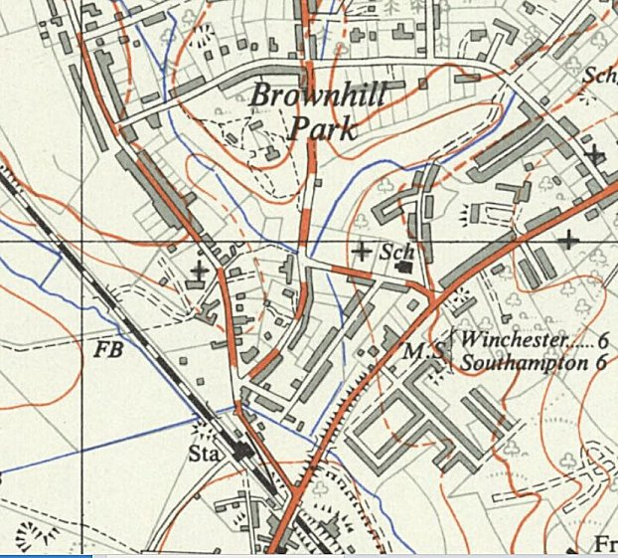
 | Ordnance Survey 1958

