Camp 556 Bucknowle House, Church Knowle, Wareham, Dorset

Included in the 1945 ICRC Camp List – Labour Camp. 556. Bucknowle House, Church Knowle, Wareham, Dorset.

Location: SY 948 813. I would expect the camp to be in the grounds of Bucknowle House.  Before the camp: Large country house and grounds.  Pow Camp:  After the camp:  Further Information: | 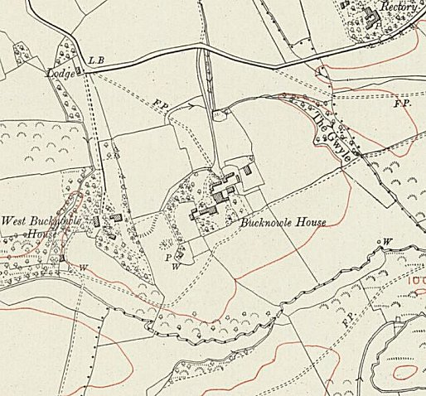
 | Ordnance Survey pre-war

