Camp 555 Newark House, Monks Meadow, Gloucester

Note: A section about this camp is included in ‘Inside The Wire’ by Ian M.C. Hollingsbee, 2014, The History Press. I therefore only detail an outline and some extra details here.  Location: On the OS map – the Dock is ‘Monk Meadow Dock’. Newark House is also shown. NGR SO 816 174.  Before the camp: Large house and estate on edge of Gloucester.  Pow Camp: Nissen huts in the estate grounds.  The camp was inspected by Dr J Wirth of the International Red Cross on 28 April 1944: Commandant Major C J MacNamara: 216 Italians in a Working Company + 2 in hospital, capacity 300. The Italian camp leader was Sergeant Major Moscatelli. There was a mixture of co-operator and non-co-operator pows.  Camp commandant c1944 C J MacNamara, I think he was with the Pioneer Corps.  Camp commandant cJanuary 1945 Major T J A Rogers  The camp closed in 1945.  After the camp:  Further Information: | 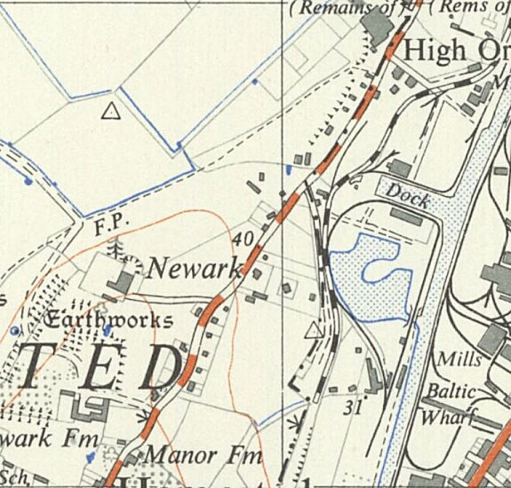
 | Ordnance Survey 1952

