Camp 554 Woodfield Farm Camp, Brockworth Road, Churchdown, Gloucestershire

Included in the 1945 ICRC Camp List – Labour Camp. 554. Woodfield Farm Camp, Brookworth Rd, Churchdown, Gloucester.

Note: A section about this camp is included in ‘Inside The Wire’ by Ian M.C. Hollingsbee, 2014, The History Press. I therefore only detail an outline and some extra details here.  Location: NGR SO 892 186. Brockworth Road is shown as ‘Green Street’ on the 1956 OS map. Another camp just 2.5 km S at Brockworth Court 142.  Before the camp: Farmland. British army camp constructed and occupied by the Pioneer Corps whose ‘Smoke Company’ provided smoke screens around strategic military and important war production industrial sites around Gloucester and Cheltenham.  Pow Camp: Italian co-operator pows from about 1943. Capacity 350. Mainly Nissen huts.  Pastscape entry – “Aerial photographs taken in 1944 show that the military/POW camp to consist of numerous Nissen type huts and other military buildings, whose layout is not regimented, but quite the reverse, being scattered across the field in clusters. There is, however, a grouping of five sets of six huts, four groups located around the perimeter of the field and one group in the centre, with a concentration of other military buildings clustered in the northeast corner of the field, along with a circular static water tank. It is possible that this rather dispersed lack of military regimentation was an attempt to confuse potential raiding enemy aircraft as to the site’s purpose, or to limit casualties/damage in the event of an air raid, but this is merely conjecture. It is logical that the five groupings of huts represent accommodation, with the remaining buildings being a mix of administrative, catering, dining, recreational, storage and other facilities. Aerial photographs taken around the end of the Second World War suggest that the camp is already no longer a military site, as many of the military huts had been demolished, leaving the concrete building platforms in the field.”  The camp was inspected by the International Red Cross on 28 April 1944: Commandant not listed: 224 Italians in a Working Company. | 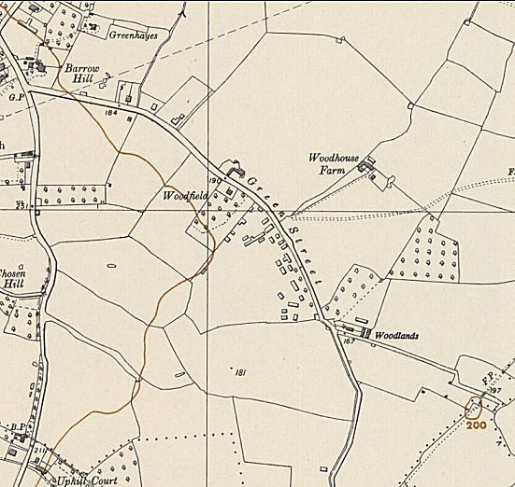
 | Ordnance Survey 1956
After the camp: Farmland / part of M5 motorway.

Further Information:

Aerial photograph - US/7PH/GP/LOC234 5041-5042 15-MAR-1944

