Camp 411 The Wynches Camp, Much Hadham, Hertfordshire

1947 Camp List
411(G.W.C.) | The Wynches, Much Hadham, Herts | E. | Priswar, Much Hadham | Much Hadham 44 | Much Hadham | Lt.Col.G.H.B. Beer | v/1453/2

Prisoner of War Camps (1939 – 1948) - Project report by Roger J.C. Thomas - English Heritage 2003
OS NGR | Sheet | No. | Name & Location | County | Cond’n | Type 1945 | Comments
TL 420 177 | 167 | 411 | The Wynches Camp, Much Hadham | Hertfordshire | 4 | German Working Camp | Restored parkland

Location: Various probable huts shown on OS map at NGR TL 423 175.  Before the camp: Camp was built early in WW2 for British troops. It later housed US troops. One report stated that there may have been Indian/Gurkha units based here.  Pow Camp: Large site, up to 40 acres. Italian and then German pows.  Camp commandant c 1947 Lieutenant Colonel G H B Beer, from the Royal Tank Regiment.  In 2010 a story was featured in many newspapers with headlines along a theme of; “Plumber finds WWII PoW camp in his back garden”. The plumber, Dave Murray, had unearthed many artefacts from WW2 including bottles, buttons, ammunition, dog tags, and a hand-grenade. Most of the finds were from a rubbish pit at the site.  After the camp: The site was demolished in 1950.  Further Information:  There was a website - www.wynchescamp411.co.uk’, but this now seems to be dead. | 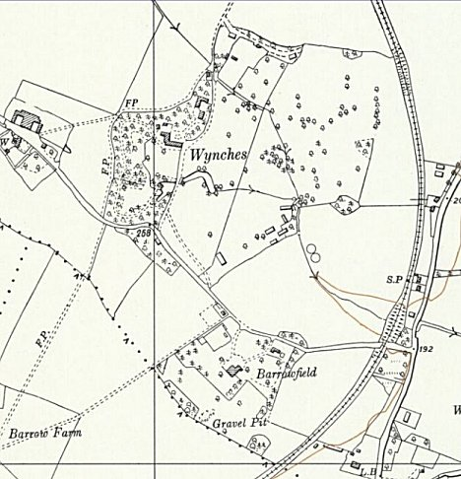
 | Ordnance Survey 1960

