Camp 409 Wolterton Camp, Aylsham, Norfolk

Prisoner of War Camps (1939 – 1948) - Project report by Roger J.C. Thomas - English Heritage 2003
OS NGR | Sheet | No. | Name & Location | County | Cond’n | Type 1945 | Comments
TG 1674 3238 | 133 | 409 | Wolterton Camp, Aylsham | Norfolk | 4 | Base Camp | Huts were located under the avenue flanking the drive and may also have been in the wood at NGR TG 1612 3190

Location: Possibly a few huts at the end of the drive near the road shown on the 1950 OS map?  Before the camp: Country House and Estate. Reports of a military base at the estate from 1940.  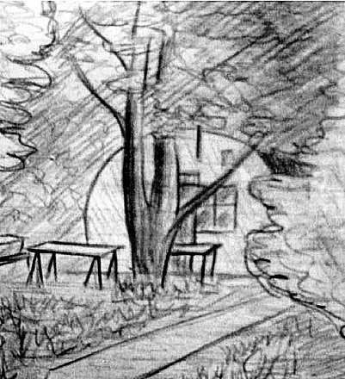  Pow Camp:  During 1946 German pows returning from the US expected to be sent to Germany, instead they arrived in the UK. One such pow was Gűnter Beetz who was sent first to Belgium, then to the UK. The sketch was made by Gűnter in 1946 of Wolterton camp, showing a Nissen type hut amongst the trees in the avenue.  After the camp: Returned to estate lands.  Further Information:  A Soldier Of The Reich - Gűnter Beetz – 2019 – Fonthill Media. Contains many pictures of his time during WW2. | 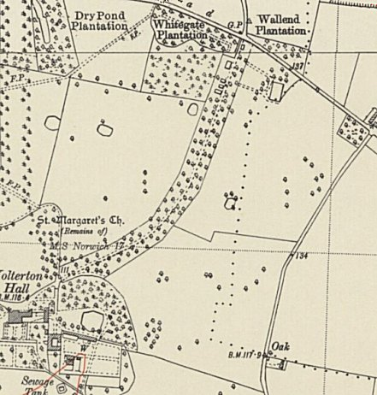
 | Ordnance Survey 1950

