Camp 408 Penclawdd Camp, Swansea, Glamorganshire

Prisoner of War Camps (1939 – 1948) - Project report by Roger J.C. Thomas - English Heritage 2003
OS NGR | Sheet | No. | Name & Location | County | Cond’n | Type 1945 | Comments
 |  | 408 | Penclawdd, Swansea | Glamorganshire |  | Base Camp | Wales

Location: Martin J Richards at www.systonimages.co.uk/ has identified 2 possible locations along the coastline. One site is a compound with NGR SS 54734 96000 – by the Salt Marsh top right on map.  Before the camp:  Pow Camp:  After the camp:  Further Information: | 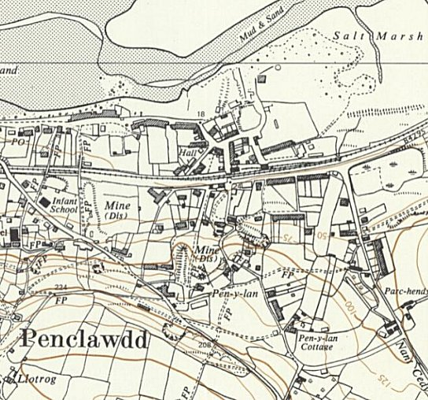
 | Ordnance Survey 1965

