Camp 405 Barwick House Camp, Barwick, Yeovil, Somerset

Prisoner of War Camps (1939 – 1948) - Project report by Roger J.C. Thomas - English Heritage 2003
OS NGR | Sheet | No. | Name & Location | County | Cond’n | Type 1945 | Comments
ST 5600 1446 | 194 | 405 | Barwick House Camp, Barwick, Yeovil | Somerset | 4 | Base Camp | Restored parkland, cropmarks visible on Getmapping coverage.

Location: The village is about 3.2km S of Yeovil.  Before the camp: Country House and Park. The park was used as a transit camp for US troops prior to D-day.  Pow Camp: Reported to have held Italian and then German pows.  After the camp:  Further Information: | 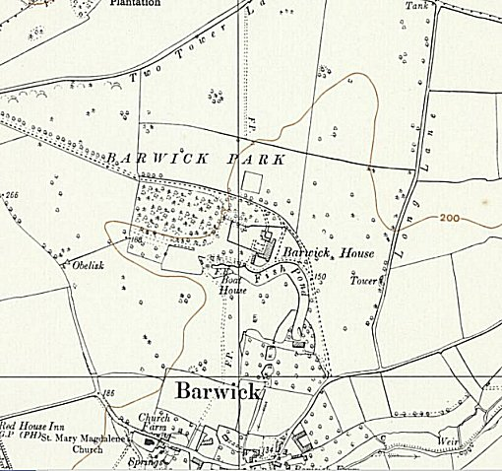
 | Ordnance Survey 1961

