Camp 403 Brockley Camp, Brockley, Somerset

1947 Camp List
403(P.C.) | Brockley Camp, Brockley, West Town, Bristol | S. | Priswar, West Town | Flax Bourton 214 | Nailsea and Blackwell (G.W.R.) | (Blank) | v/202/4

Prisoner of War Camps (1939 – 1948) - Project report by Roger J.C. Thomas - English Heritage 2003
OS NGR | Sheet | No. | Name & Location | County | Cond’n | Type 1945 | Comments
ST 475 671 | 171 | 403 | Brockley Camp, Brockley | Somerset | 4 | Base Camp | Restored parkland.

Location:  Before the camp:  Pow Camp: Capacity up to 500 pows.  Wikipedia – “Brockley was the location of a 300-person Prisoner of War camp during World War 2, initially housing Italian prisoners from the Western Desert Campaign, and later German prisoners post the Battle of Normandy.”  After the camp:  Further Information:  National Archives FO 939/317 – 403 Working Camp, Brockley Camp, Bristol. Dated 1946 - 1947 | 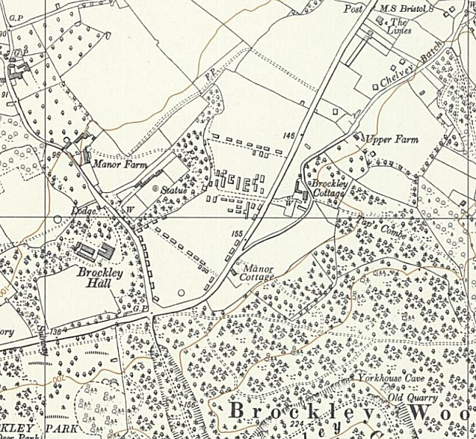
 | Ordnance Survey 1960

