Camp 402 Lopcombe Corner Camp, Salisbury, Hampshire (aka Lopscombe)

Prisoner of War Camps (1939 – 1948) - Project report by Roger J.C. Thomas - English Heritage 2003
OS NGR | Sheet | No. | Name & Location | County | Cond’n | Type 1945 | Comments
SU 252 355 | 117 | 402 | Lopscombe Corner Camp, Salisbury | Wiltshire | 5 | Base Camp | Precise location not identified, NGR given for the village.

Location:  Before the camp: Considering it is such a small place, various forces are recorded as having been at ‘Lopscombe Corner’ – 18th Australian Brigade in 1940 – US 1st and 3rd Battalions, Anti-tank Company and Cannon Company in 1944 and various maintenance units.  Pow Camp: The only reference I have found was a mention that a German pow was briefly at the camp in April 1947.  After the camp:  Further Information: | 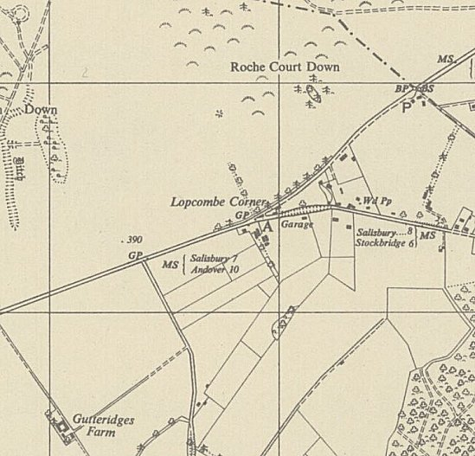
 | Ordnance Survey1958

