Camp 299 Godwin Camp, Kilnsea, Hull, East Yorkshire

Included in the 1945 ICRC Camp list – Labour Camp. 299. Godwin Camp, Kilnsea, Patrington, Hull, Yorks.

Location: NGR TA 414 158. Kilnsea is about 3.7 km SE of Easington at the top of Spurn head. The site is named after the nearby Godwin Military Fort.  Before the camp: Farmland. WW2 Army camp.  Pow Camp: The army camp was converted in 1942/43 to be a pow camp for Italian pows. Nissen huts.  Later housed German pows.  Memories - Eduard Friedrich Winkler was a German pow at Kilnsea Camp in 1946 or 1947. He stated that the camp was near to the Blue Bell Inn (at the crossroads). The pows were employed mainly on coastal sea defences. During his time an inspection was carried out by a South African officer. Eduard was teaching English at the camp.  After the camp: Site cleared in 1985.  Further Information:  IWM – recording of Eduard Winkler available online, (Reel 5 – Catalogue 18523). | 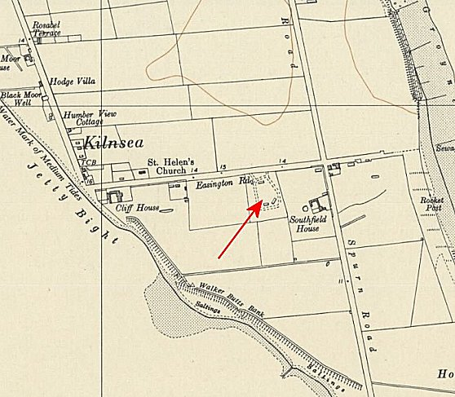
 | Ordnance Survey 1956

