Camp 295 Cattistock Camp, Maiden Newton, Dorset

1947 Camp List
295(G.W.C.) | Cattistock Camp, Cattistock, Dorchester, Dorset | S | Priswar, Cattistock | Maiden Newton 323 | (Blank) | Lt.Col.W.H.Rowe | v/1453/2

Prisoner of War Camps (1939 – 1948) - Project report by Roger J.C. Thomas - English Heritage 2003
OS NGR | Sheet | No. | Name & Location | County | Cond’n | Type 1945 | Comments
SY 592 996 | 194 | 295 | Cattistock Camp, Cattistock, Maiden Newton | Dorset | 5 | German Working Camp | Precise location not identified, NGR given for village.

Location: Cattistock is about 13km NW of Dorchester. Site shown at SY 590 996.  Before the camp: Some military use noted at the site.  Pow Camp: Italian pows then a German working camp from 1945.  Georg Kroemer was a German pow who had been held in the US where he made three escape attempts. He was shipped to the UK in 1946: “…We thought we were going to Germany. After we had crossed the Atlantic, however, we found out through a translator that our destination was England. Our morale plummeted.  We arrived in Liverpool and were promptly whisked away to Camp Cattistock, north of Dorchester. When we got to the camp, we had to empty the contents of our duffel bags under the watchful eyes of English guards. Personal possessions we were allowed to keep, but all other items that we had bought, such as cigarettes, coffee, and chocolate, were confiscated. The English took these things to the camp canteen and redistributed a small portion free of charge to every POW in the camp.  During the next thirteen months, I worked in agriculture at several branch camps near Cattistock. By the end of March 1947, so many of my comrades had been repatriated that I decided to do something I hoped would get me back home. One day I wandered away from the branch camp and hid in a haystack until I was found. I was taken to Cattistock and put into the calaboose. I vowed a hunger strike and began a masquerade of paranoia. I didn’t actually go hungry because a good friend of mine who worked in the camp bakery slipped me bread.” Georg feigned an instance of madness, was assessed, and was repatriated a week or so later. (From German Prisoners of War at Camp Cooke, Clifornia, by Jeffrey E Geiger).  Camp monthly magazine was called Aufbau (Construction). | 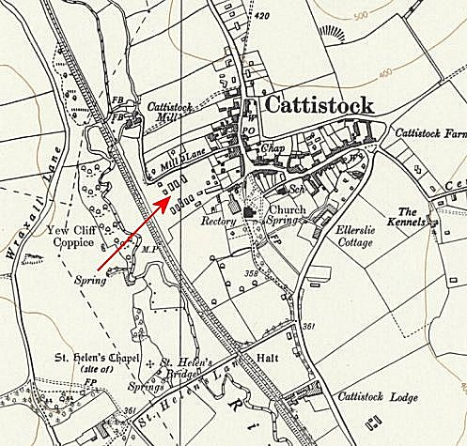
 | Ordnance Survey 1961
Camp commandant c1947 Lieutenant Colonel W H Rowe. I think he was with the Pioneer Corps.
Probably several sub-scamps + hostels – found:
Beaminster I and II – in the grounds of Parnham House

Clay Hill, Burton Bradstock – NGR SY 4934 8897 - Former Army Camp, then pow sub-camp. 1947 aerial photograph (Run 2475, frame 3073) shwed 16 wooden huts. National Trust record states it was “constructed in the early part of WW2 for coastal defence units. However, by about 1943, the camp became a satellite [to] Prisoner-of-War Camp 295 at Cattistock and was initially used for Italian PoWs employed on local farms.” (NT Record 110622/MNA168513).

After the camp: 2020 residential area.
Further Information:
National Archives FO 1120/244 – Re-educational survey visit reports for camps 294 to 298. Dated 1 January 1946 – 31 December 1948

The German Federal Archive has a copy of the camp magazine.

