Camp 290 South Lane Camp, Barrows Green; Lancashire (aka Penketh Hostel Camp)

Included in the 1945 ICRC camp list – Labour Camp. 290. South Lane Camp, Barrow Green, Bold, Widnes, Lancs.

Prisoner of War Camps (1939 – 1948) - Project report by Roger J.C. Thomas - English Heritage 2003
OS NGR | Sheet | No. | Name & Location | County | Cond’n | Type 1945 | Comments
SJ 5416 8789 | 108 | 290 | Penketh Hostel, South Lane Farm, South  Lane, Barrow's Green | Lancashire | 3 | German  Working Camp | Former Heavy Anti-aircraft battery  (HAA Bty)

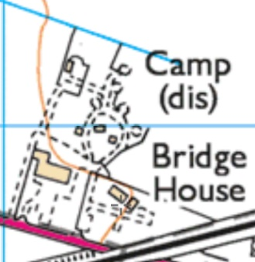  Location: The ‘hostel’ is shown on the 1954 OS map. On the modern map inset, the pow site is now Bridge House – the ‘Camp(dis)’ is where the Barrows green 3.7” HAA Battery was located as one of the sites protecting the huge RAF/USAAF airbase at Burtonwood.  Before the camp: Farmland  Pow Camp: Initially held low risk Italian pows in the Royal Artillery barrack huts. By 1945 it held German pows.  The Pastscape heritage report states that the camp was used after the battery was closed down.  There is still a tower which is argued to be - a water tower / guard tower / gun and searchlight placement (Pastscape stated it was a water tank).  After the camp: Used for a short time as a hostel for displaced people.  Further Information:  National Archives FO 1120/243 – Re-educational survey visit reports for camps 286 to 293. Dated 1 January 1946 – 31 December 1948 | 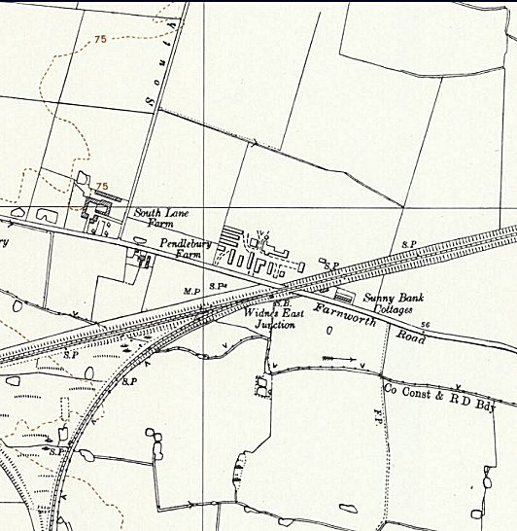
 | Ordnance Survey 1954

