Camp 289 Lydiard House, Lydiard Millicent, nr Swindon, Wiltshire

Included in the 1945 ICRC Camp List – Labour Camp. 289. Lydiard House, Lydiard Millicent, Swindon, Wilts.

1947 Camp List
289(G.W.C.) | Lydiard House, Lydiard Millicent, Swindon, Wiltshire | S | Priswar, Swindon | Purton 224 | Swindon | Major H.S.A.Keynton | v/1452/2

Prisoner of War Camps (1939 – 1948) - Project report by Roger J.C. Thomas - English Heritage 2003
OS NGR | Sheet | No. | Name & Location | County | Cond’n | Type 1945 | Comments
SU 0899 8621 | 173 | 289 | Lydiard House, Lydiard Millicent, Swindon | Wiltshire | 4 | German Working Camp | Camp associated with a military hospital.

Location: Lydiard House (Camp 289) at Lydiard Millicent was not the same as Lydiard Park and House (Camp 160), they are about 2km apart. Lydiard Millicent is about 6km W of Swindon.  The map shows two possible sites. Just to the west of the house is a small group of buildings / to the east is a quadrilateral area.  Before the camp:  Pow Camp: Details about Camp 160 have been added to some of the published information about this camp assuming that they were the same place.  The rank of the commandant and War Establishment number shows that it was a fairly small camp by 1947.  Camp Commandant c1947 Major Harold Stanley Ambrose Keynton. He was with the Tank Corps in WW1, - I think he moved to the Somerset Light infantry.  After the camp:  Further Information:  National Archives FO 1120/243 – Re-educational survey visit reports for camps 286 to 293. Dated 1 January 1946 – 31 December 1948  Wiltshire and Swindon History Centre – have a letter reference F5/505/5 - ‘Letter Apr'45 from Acting Chief Constable of Wiltshire to Estate Surveyor, Ministry of Works re. using War Department site at Lydiard Millicent to house 500 Italian POWs (non-co-operative) as alternative to Crowdys Field, Cricklade Road, Swindon’. | 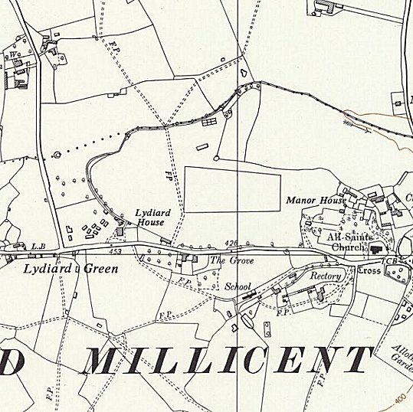
 | Ordnance Survey 1960

