Camp 286 (& 654 / 655) Purfleet Camp, Beacon Hill, Purfleet, Essex

1947 Camp List
286(G.W.C.) | Purfleet Camp, Purfleet, Essex | E. | Priswar, Purfleet | Rainham, Essex 2911 | Purfleet | Lt.Col.C.W.Hughes | v/1453/2

655(G.W.Coy) | E | No.1 Transit Camp, Purfleet, Essex | Rainham 2726 Ext.5 | 71(W.O.) | V/1270/4

Prisoner of War Camps (1939 – 1948) - Project report by Roger J.C. Thomas - English Heritage 2003
OS NGR | Sheet | No. | Name & Location | County | Cond’n | Type 1945 | Comments
TQ 5584 7846 | 177 | 286 | Purfleet Camp, Beacon Hill, Purfleet | Essex | 4 | German  Working Camp | Guards' compound consisted of huts, prisoners' compound consisted of tented accommodation within a rectangular wire enclosure.  (See Camp no.286 / 654 / 655).
 |  | 654 | No.4 Transit Camp, Beacon Hill, Purfleet
 |  | 655 | No.1 Transit Camp, Beacon Hill, Purfleet

Qs about the entries above. Are they the same camp? Same location? Where were Transit Camps 2 and 3? (There were also 2 transit camps located in Harwich – 680 and 740 – might these be 2 and 3?).  Location:  Before the camp: The area was in use by the military for many reasons. There was a Dispersal Camp for troops which closed in 1920. The site was part of the huge Marshalling Areas prior to D-Day.  Pow Camp: Camp 286 appears to be separate from 664/665 – this is indicated, for example, in a report on the visits of the German Social Democratic politician and anti-Nazi, Walter Auerbach, where the Foreign Office praised his, “excellent reports on your visit to 654/655 and 286 PW camps.”  The 2 Transit Camps (+Tillingham) may have been satellite camps for the larger camp 266 at Langdon Hills.  Camp 654 was visited by Walter Auerbach in October 1945 when he commented on Nazi influences within camps:  “There was no organized opposition, but it seems that the back benches of the tent were occupied by groups of “blacks”. [i.e. Black Category C; Nazi pows] There were 16 contributions to the discussion, one of the debaters spoke three times and tried to start another time. He is a Luftwaffen-Feldwebel, soldier by profession, and is faithfully repeating the Nazi lectures he attended. A large part of the audience tried to boo him down when he spoke of the Fűhrer and the German superiority above all nations.” (Auerbach: Report: Camp 654 (Purfleet, North Camp), 5.10.1945 – quoted in ‘Walter Auerbach, Sozialpolitik aus dem Exil’ by Ellen Babendreyer). | 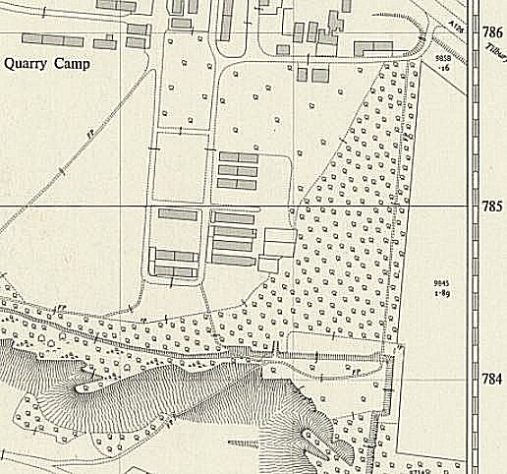
 | Ordnance Survey 1953
Memories – “Purfleet was a large camp with quite a few thousand prisoners. I arrived in March 1946. We slept 8 in a tent with just wooden flooring. It was very primitive, like in the Army. It wasn’t very nice with thousands of people and nothing much to do really. We were taken out to work every day by lorry, but at night time what could we do…. Play football, as much as poss, play table tennis. We did have quite a bit of help from the YMCA; they supplied musical instruments, proper footballs, football boots and books. They made quite an impact, it was quite something what they did for us and it was very much appreciated.
Every day some people were taken to work on farms, others to Romford to work on a building site….”
(BBC People’sWar; Contributor Josef Kox; Article ID: A7564548)
There was a camp newspaper – ‘Der Anruf Purfleet’ (The Call or voice).
After the camp:
Further Information:
National Archives –
FO 939/320 – 654 Working camp, Purfleet camp, Tilbury, Essex. Dated 1945 – 1946.

FO 1120/243 – Re-educational survey visit reports for camps 286 to 293. Dated 1 January 1946 – 31 December 1948

IWM have a copy of the camp newspaper dated 28 February 1947. Catalogue LBY E.J.334

