Camp 284 Swanbridge Camp, Penarth, Glamorganshire

Prisoner of War Camps (1939 – 1948) - Project report by Roger J.C. Thomas - English Heritage 2003
OS NGR | Sheet | No. | Name & Location | County | Cond’n | Type 1945 | Comments
 |  | 284 | Swanbridge, Sully | Glamorganshire |  |  | Wales

Location:  Before the camp:  Pow Camp:  After the camp:  Further Information:  National Archives FO 1120/242 – Re-educational survey visit reports for camps 279 to 284. Dated 1 January 1946 – 31 December 1948 | 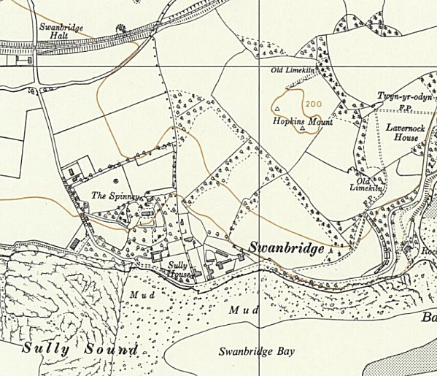
 | Ordnance Survey 1964

