Camp 284 Abbey Road Camp, Neath, Glamorganshire

1947 Camp List
284(G.W.C.) | Abbey Road Camp, Neath, Glamorgan | W. | Priswar, Neath | Neath 922 | (Blank) | Major F.H.Mann | v/1452/2

Prisoner of War Camps (1939 – 1948) - Project report by Roger J.C. Thomas - English Heritage 2003
OS NGR | Sheet | No. | Name & Location | County | Cond’n | Type 1945 | Comments
 |  | 284 | Abbey Road Camp, Neath | Glamorganshire |  | German Working Camp | Wales

Location: I have assumed the road was ‘Neath Abbey Road’ – highlighted on the map.  Before the camp:  Pow Camp:  Memories – “In the middle of the war, Italian prisoners of war kept in a camp on Neath Abbey Road, Neath, often times worked outside on a farm in Bryncoch, which was close to The Dyffryn Arms public house, under the supervision of the camp guards. The same Italian soldiers were put to work clearing an area about 10 or 15 yards diameter in the midst of a copse of trees.” (By ‘littletom brown’ – BBC People’sWar – Article A7819752).  A brief mention in the House of Commons, 1947, (is this a reference to the camp or to billets?):  “Mr. D. J. Williams asked the Secretary of State for War when the buildings at Abbey Road, Neath, Glamorganshire, now used to accommodate prisoners of war, will be vacated; and if he is aware that the Neath Borough Council is anxious to make use of these buildings for housing purposes in view of the serious housing problem locally.  Mr. Shinwell - I am not yet in a position to make a statement about the future use of this accommodation.” (Hansard, 16 December 1947, Vol 445).  After the camp:  Further Information: | 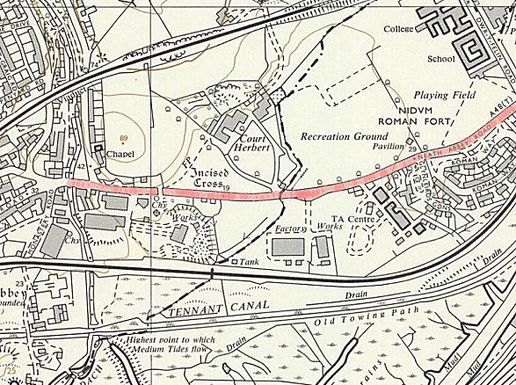
 | Ordnance Survey 1964

National Archives FO 1120/242 – Re-educational survey visit reports for camps 279 to 284. Dated 1 January 1946 – 31 December 1948

