Camp 283 War Department Camp, Ledsham Hall, Cheshire

1947 Camp List
283(G.W.C.) | W.D.Camp, Ledsham Hall, Ledsham, Little Sutton, Wirral, Cheshire | W | Priswar, Little Sutton | Hooton 3304 | Ledsham | Major F.S.Eaton T.D. | v/1452/2

Prisoner of War Camps (1939 – 1948) - Project report by Roger J.C. Thomas - English Heritage 2003
OS NGR | Sheet | No. | Name & Location | County | Cond’n | Type 1945 | Comments
SJ 3528 7594 | 117 | 283 | W.D. Camp, Ledsham Hall, Ledsham, Little Sutton | Cheshire | 3 | German  Working Camp | Large complex of tented  accommodation with a small number of huts

Location: Possible huts shown on map just below Ledsham Hall.  Before the camp: Reports of a US army camp at this site from 1943 to 1944.  Pow Camp:  Camp commandant c1947 Major F S Eaton T.D., with the Lancashire Fusiliers.  Letter-sheet seen dated 22 February 1947 to Germany.  After the camp:  Further Information:  National Archives FO 1120/242 – Re-educational survey visit reports for camps 279 to 284. Dated 1 January 1946 – 31 December 1948 | 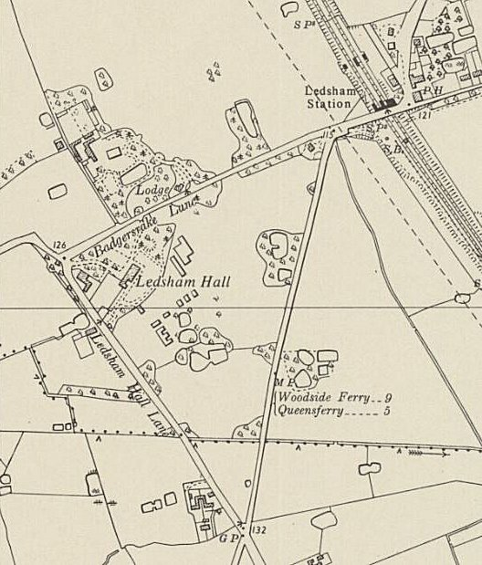
 | Ordnance Survey 1954

