Camp 282 Brissenden Green Camp, Brissenden, Kent

Prisoner of War Camps (1939 – 1948) - Project report by Roger J.C. Thomas - English Heritage 2003
OS NGR | Sheet | No. | Name & Location | County | Cond’n | Type 1945 | Comments
TQ 941 393 | 189 | 282 | Brissenden Green Camp, Brissenden, Ashchurch | Kent | 5 |  | Precise location not identified, NGR given for village.

Location: Brissenden Green with Potter’s Farm bottom left of map.  Before the camp:  Pow Camp: Believed to have been on land close to Potters Farm.  A website gives a history of the farm - “Following discussions in 1990s with the children of the owners of Potters Farm at that time, it was confirmed that Italians were held in a camp in 20 acre Wood (to the East of the Farm) and that these prisoners made the children on the farm necklaces of coloured beads. This is in line with experience at other Italian camps were the internees created chapels as well as colourful and creatively decorated camp accommodation. Like many other camps, no remnants from the camp remain as these were dismantled at the end of the war when the land was returned to agricultural production.”  www.pottersfarm.co.uk  In October 1947 it is listed as a satellite to Camp 86 Stanhope.  After the camp:  Further Information: | 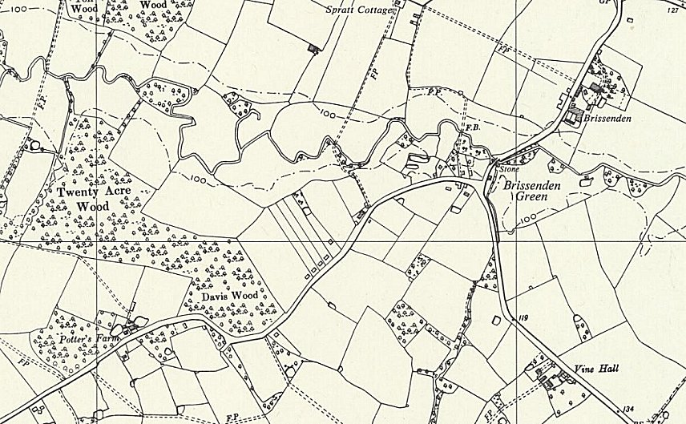
 | Ordnance Survey 1961

National Archives FO 1120/242 – Re-educational survey visit reports for camps 279 to 284. Dated 1 January 1946 – 31 December 1948

