Camp 281 Aldborough Camp, Norwich, Norfolk

Prisoner of War Camps (1939 – 1948) - Project report by Roger J.C. Thomas - English Heritage 2003
OS NGR | Sheet | No. | Name & Location | County | Cond’n | Type 1945 | Comments
 |  | 281 | Aldburgh (Aldborough) Camp, Norwich | Norfolk | 5 | German Working Camp | No satisfactory location could be found near Norwich.

The location comment is a little strange as Aldborough is some 26 km N of Norwich. I cannot race an ‘Alburgh’ so I also assume the spelling in brackets is correct. Aldborough Hall is located NW of Aldborough village at TG 1698 3506

Location:  Before the camp:  Pow Camp:  After the camp:  Further Information:  National Archives FO 1120/242 – Re-educational survey visit reports for camps 279 to 284. Dated 1 January 1946 – 31 December 1948 | 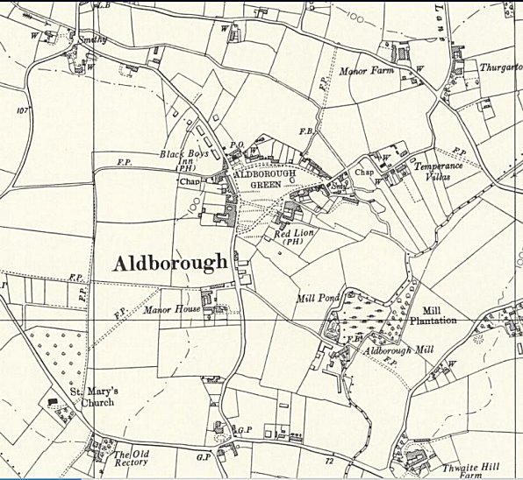
 | Ordnance Survey 1957

