Camp 280 North Lynn Farm Camp, King's Lynn, Norfolk

1947 Camp List
280(G.W.C.) | North Lynn Farm Camp, Kings Lynn, Norfolk | E | Priswar, Kings Lynn | Kings Lynn 2939 | Kings Lynn | Lt.Col.J.A.L.Powell | v/1453/2

Prisoner of War Camps (1939 – 1948) - Project report by Roger J.C. Thomas - English Heritage 2003
OS NGR | Sheet | No. | Name & Location | County | Cond’n | Type 1945 | Comments
TF 6140 2152 | 132 | 280 | North Lynn Farm Camp, Kings Lynn | Norfolk | 4 | German Working Camp | STANDARD type. Site occupied by a chemical works.

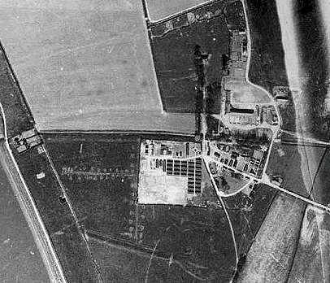  Aerial photograph taken in 1946. | 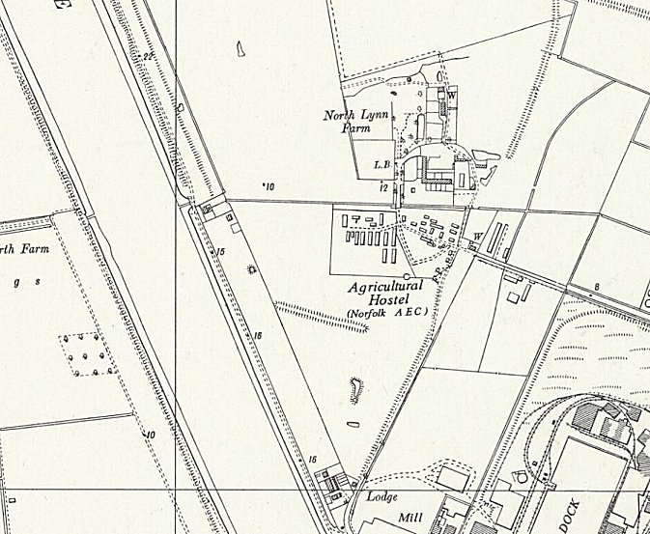
 | Ordnance Survey 1958
Location: Shown as an Agricultural Hostel on 1958 OS map.
Before the camp:
Pow Camp: Mainly Nissen huts. Standard type pattern for the camp with a main pow compound and separate guards / office compound towards the ‘front’.
Pastscape report stated that the camp was constructed between June 1945 and April 1946:
“The main body of the site consists of five closely spaced parallel rows of huts centred on TF 6140 2150. To the north west of these are three tall structures. The function of these is not clear from the aerial photographs, but they may be observation towers or masts of some sort. To the north of the prisoners' accommodation is an ornamental garden consisting of a square parterre, centred on TF 6142 2154. According to Roger Thomas' report ornamental knot gardens and formal flower borders are a common feature of PoW camps. To the east of the site, centred on TF 6150 2151, are more military huts and buildings. These are less closely spaced than the rows and are probably for military personnel rather than prisoners. Centred on TF 6145 2150 are three circular structures, 3.5m in diameter, which have the appearance of storage tanks, possibly for water. To the west of the site there are two straight trenches, recently dug, flanked on either side by small pits. These have the appearance of defensive trenches and weapons pits, although it is possible that they are the lines of earlier ditches or drains recently recut. Centred on TF 6133 2146 is an area of cleared ground, which reveals the former location of more structures. Also visible are the exposed soilmarks of a partial ring ditch and linear feature. The date of these is unknown. Although they may also relate to earlier military structures or perhaps relate to the Medieval to Post Medieval activity on this site (NHER 27889).”
Incidental information from a German theatre group journal held by the Deutsches Historisches Museum. The group toured pow camps around England during 1946. It recorded its visit to North Lynn Farm Camp, 280 in late 1946.

Army discharge papers seen for a guard at the camp dated June 1947, (forum below).

After the camp: Used as a hostel under the European Voluntary Workers scheme and as temporary emergency housing. 2020 Riverside Industrial Estate
Further Information:
National Archives FO 1120/242 – Re-educational survey visit reports for camps 279 to 284. Dated 1 January 1946 – 31 December 1948
https://www.kingslynn-forums.co.uk/viewtopic.php?f=14&t=2961 – with pictures of the site as a hostel.

