Camp 278 War Department Camp, Clapham, Bedfordshire

1947 Camp List
278(G.W.C.) | W.D. Camp, Clapham, Bedford | E | Priswar, Bedford | Bedford 4868 | Bedford (L.M.S.) | Lt.Col.A.B.Rogers | v/1453/2

Prisoner of War Camps (1939 – 1948) - Project report by Roger J.C. Thomas - English Heritage 2003
OS NGR | Sheet | No. | Name & Location | County | Cond’n | Type 1945 | Comments
TL 0238 5350 | 153 | 278 | W.D. Camp, Clapham, Bedford | Bedfordshire | 5 | German Working Camp | Two possible sites, other possibility is at TL 0071 5464

Location: The camp was beside Green Lane which runs N from Tollgate Cottage on the map. Site shown (are those pow huts? there was a chicken farm there later) at TL 036 523 next to Tollgate Cottage and Woodlands.  Before the camp:  Pow Camp: There are 2 photographs of the camp in Stephen Rigsby’s book. Open by April 1945. Pows worked in the Lidlington and Ridgemont Brickworks. Mixed huts and tents.  A death was recorded of a pow – Willi Lizeba, aged 20, died 20 October 1947. This was raised in the House of Commons:  “Mr. Skeffington-Lodge asked the Secretary of State for War whether he will make a statement about the recent road accident in Bedfordshire in which one' prisoner of war from Clapham Camp was killed and four others injured, such statement to cover the arrangements he is making in the matter of compensation.  Mr. Shinwell - On 20th October a lorry driven by a civilian was transporting prisoners of war from their camp to their work when it became involved in a road accident near Bedford with a lorry belonging to the Women's Land Army. As a result of the accident five prisoners of war were injured and of these one has died in hospital. The inquest has been adjourned for 10 days. As regards compensation in respect of the prisoner of war who has died, I would refer my hon. Friend to the reply to Question No. 9 today. With regard to the prisoners of war who were injured, they will be dealt with under the scheme announced in reply to a Question by my hon. Friend the Member for Maldon (Mr. Driberg) on 1st July.  Mr. Quintin Hogg - With regard to this question of compensation, surely the refusal of the right hon. Gentleman is really repugnant to the dictates of civilised humanity? Were not these people who were killed Service men, no matter whether they were Hottentots or Germans, and are not their relatives entitled to compensation? | 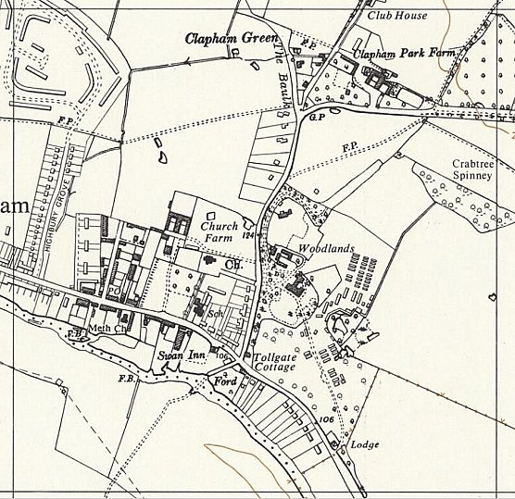
 | Ordnance Survey 1960
Mr. Shinwell - The principles of the Geneva Convention in this respect are universally applied. We cannot apply one system here and another system elsewhere. I have already said, in reply to an earlier Question, that I am reviewing certain aspects of this case.” (Hansard, 28 October 1947, Volume 443)

After the camp: There was a further brief mention of the camp and the future of the site in the House of Commons:

“Mr. Skeffington-Lodge asked the Minister of Works what decision has been reached regarding the future use of the camp at Clapham, Bedfordshire, previously in occupation by German prisoners of war.

Mr. Key - Part of Clapham Camp will be used by the Territorial Army, and the remainder will probably be used as a sorting depôt by the Ministry of Food.” (Hansard, 21 September 1948, Volume 456)

Further Information:
Prisoners of War in Bedfordshire – Stephen Risby – Amberley – 2011.
National Archives FO 1120/241 – Re-educational survey visit reports for camps 276 to 278. Dated 1 January 1946 – 31 December 1948

