Camp 277a Fladbury Golf Course, Fladbury, Worcestershire

Prisoner of War Camps (1939 – 1948) - Project report by Roger J.C. Thomas - English Heritage 2003
OS NGR | Sheet | No. | Name & Location | County | Cond’n | Type 1945 | Comments
SO 997 470 | 150 | 277a | Fladbury Golf Course, Fladbury, Pershore | Worcestershire | 4 |  | Site occupied by a golf course

Location: The shape indicated on the OS map may be the border fence for the pow camp.  Before the camp:  Pow Camp: The number of the camp suggests it was a satellite camp for Camp 277 at South Littleton?  Memories – “Somewhat more unusually there were Americans based mostly in tents on the golf course up at the crossroads and along the river…..  …The Yanks left a sentry box, (like seen in POW films) just inside and to the left of the Blue Gate field which was immediately over the railway bridge and running alongside the railway line. This sentry box was used again when later on the camp on the golf course was used to house German and Italian prisoners of war. These prisoners wore a uniform with a large ring on the back. They mostly did agricultural work.” (BBC People’s War – Contributed by Audrey Jean Wall, Article A4142170).  There was a camp newspaper ‘Der Brűcke’ (The Bridge).  After the camp: 2020 Evesham Golf Course.  Further Information:  National Archives FO 1120/241 – Re-educational survey visit reports for camps 276 to 278. Dated 1 January 1946 – 31 December 1948  The German Federal Archive has a copy of the camp magazine. | 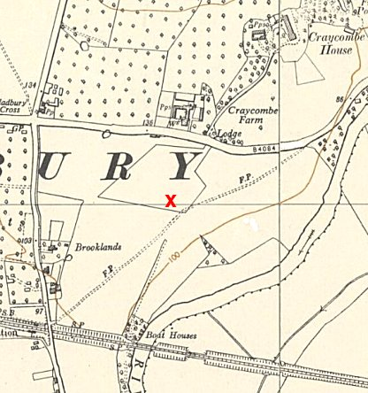
 | Ordnance Survey 1954

