Camp 276 Nissen Creek, Pinhoe, Exeter, Devon

1947 Camp List
276(G.W.C.) | Nisson Creek, Pinhoe, Nr.Exeter | S | Priswar, Pinhoe, Clyst | Exeter 67416 | (Blank) | Lt.Col.D.W.Hunter-Blair | v/1453/2

Prisoner of War Camps (1939 – 1948) - Project report by Roger J.C. Thomas - English Heritage 2003
OS NGR | Sheet | No. | Name & Location | County | Cond’n | Type 1945 | Comments
SX 963 941 | 192 | 276 /276a | Nissen (Nisson) Creek, Pinhoe, Exeter | Devon | 5 | German Working Camp

Location: Pinhoe is just NE of Exeter.  There was another camp called ‘Nissen Creek’ which was a temporary accommodation camp for the WAAF at SX 968 956 about 1.5km NE of the POW camp.  Before the camp: Farmland  Pow Camp:  Camp commandant c 1947 Lieutenant Colonel D W Hunter-Blair, from the Gordon Highlanders.  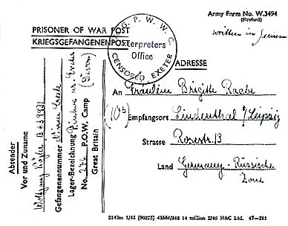  <1947 pow postcard.  After the camp: 2020 recreation ground / residential.  Further Information:  National Archives -  FO 1120/240 – Re-educational survey visit reports for camps 266 to 276. Dated 1 January 1946 – 31 December 1948  FO 1120/241 – Re-educational survey visit reports for camps 276 to 278. Dated 1 January 1946 – 31 December 1948 | 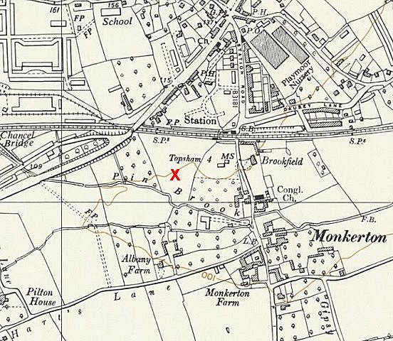
 | Ordnance Survey 1963

IWM – ‘Private Papers of W G Torr’. “Official and private correspondence dating mainly from 1946-1948 (circa 40 items) concerning William Torr’s work as a Society of Friends (Quaker) Welfare Visitor at POW camps in the Exeter area, in particular Camp 276 at Dymonds Farm, Honiton Clyst (later at Pinhoe), including: official letters and documents from the Friends Committee for Refugees and Aliens regarding Visitor access to POW camps and information for the guidance of local clergy in dealings with POW chaplains and the provision of church services to POWs; letters written to Torr and his family by German former POWs and their families (in German and English), expressing their gratitude to him and the Society of Friends generally for the friendship and support given to POWs in the camps and after their return to Germany, many of the letters also referring to social and economic conditions in postwar Germany; with some miscellaneous related papers and photographs, including one of Torr and his family outside their home in Exeter, 1946.” Catalogue Documents.16615. [Dymonds Farm was camp 76 / 276].

