**Camp 273** **/ 273a Debach Airfield, Debach, Suffolk**

|  |  |  |  |  |  |  |  |
| --- | --- | --- | --- | --- | --- | --- | --- |
| 1947 Camp List | | | | | | | |
| 273(G.W.C.) | Debach Airfield, Woodbridge, Suffolk | E. | Priswar, Woodbridge | Woodbridge 235 | Woodbridge | Lt.Col.F.A.Levis | v/1453/2 |

|  |  |  |  |  |  |  |  |
| --- | --- | --- | --- | --- | --- | --- | --- |
| **Prisoner of War Camps (1939 – 1948) - Project report by Roger J.C. Thomas - English Heritage 2003** | | | | | | | |
| OS NGR | Sheet | No. | Name & Location | County | Cond’n | Type 1945 | Comments |
| TM 2287 5404 | 156 | 273 /273a | Debach Airfield, Debach, Woodbridge | Suffolk | 5 | German Working Camp | Former RAF Debach (Station 152). Precise location not identified, NGR given for approx centre of the numerous dispersed accommodation sites. |

|  |  |
| --- | --- |
| **Location:** Information from <https://www.systonimages.co.uk/> - “*The Visitor centre includes an airfield map along with an information poster on Thistleton Hall that formed the PoW Camp and was demolished post war. The museums also contain extensive WWII displays including that of toys and other items produced by and associated with the PoWs…*  *This site (TM 2357 5310 ‘X’) is now a small woodland a few hundred metres from the Control Tower. A PoW Sub Camp can be found close to the original English Heritage original coordinates in what is now a Golf Equipment Producer which has retained the original main buildings.*” (TM 2307 5407).  **Before the camp:** Farmland requisitioned at the start of the war. Airfield built in 1942/1943. Used by USAAF from 1944 to 1945.  **Pow Camp:** Used as a pow camp from 1945. Mainly Nissen huts.    < Camp token money. Could only be used in the camp of issue.  **After the camp:** Used for a short time to accommodate displaced persons. Mixed use  **Further Information:**  The 493rd Bomb Group Museum has information and displays about the powcamp – well worth a visit. |  |
| Ordnance Survey 1958 |

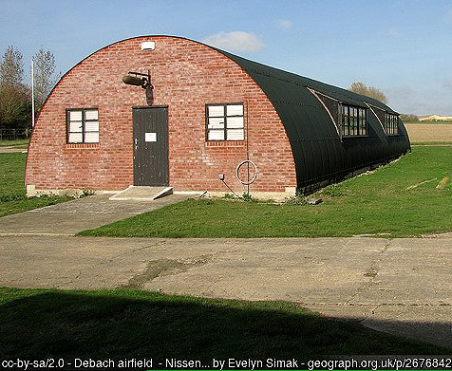Their website has some photos of pows at the camp. Check opening times as the museum is not open all year; <https://493bgdebach.co.uk/pow>

National Archives FO 1120/240 – Re-educational survey visit reports for camps 266 to 276. Dated 1 January 1946 – 31 December 1948

FO 939/275 – details of an ‘Exhibition: 273 Camp, Debach Airfield Camp, Woodbridge, Suffolk’. Dated 1946-1948. Exhibitions were held at camps, usually created by the pows themselves as part of a re-education programme controlled by the Control Office for Germany and Austria (COGA). Political themes such as ‘democracy’ were often the theme for the displays.