Camp 272 / 272a Davenport House, Worfield, Shropshire

Prisoner of War Camps (1939 – 1948) - Project report by Roger J.C. Thomas - English Heritage 2003
OS NGR | Sheet | No. | Name & Location | County | Cond’n | Type 1945 | Comments
SO 754 954 | 138 | 272 / 272a | Davenport House, Worfield, Bridgnorth | Shropshire | 4 | German Working Camp | STANDARD type.

Location: There is mention of the camp being at ‘Hallon’ which is at the NE of the estate.  Before the camp: A camp for 2,500 troops was built in the grounds November 1943 to March 1944. A pumping station was built to supply the camp and Worfield and Bradney villages. US troops were stationed here.  Pow Camp:  Memories – “When the Americans no longer needed Camp Davenport it was used by prisoners of war, Italians and Germans. They were taken out daily by the WARAG to work on farms and there were different uniforms for Italians and Germans. In their spare time they made craft items such as slippers and entertained themselves by singing. Bob Adams described how you could hear them singing in the evenings and they were as good as any male voice choir.  The Worfield people welcomed the newcomers into their midst and local businesses presumably felt the benefit of the extra trade. When the Americans had left Davenport the prisoners of war brought labour which must have been a great boon to the farmers.” (From an article entitled; ‘Worfield During and After the War’, compiled from memories provided by Bob Adams and a book by Adrian and Neil Turley entitled 'The US Army in South East Shropshire 1944.').  Postal items: Letter-sheet to Germany dated January 1947 where the camp address is ‘Satellite Camp Worfield’.  After the camp:  Further Information:  National Archives FO 1120/240 – Re-educational survey visit reports for camps 266 to 276. Dated 1 January 1946 – 31 December 1948 | 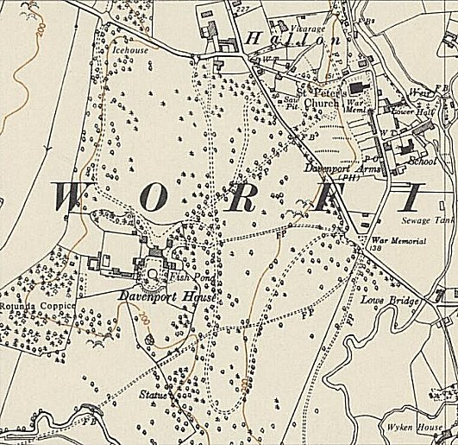
 | Ordnance Survey 1954

