Camp 271 RAF Airfield, Attleborough, Norfolk

Prisoner of War Camps (1939 – 1948) - Project report by Roger J.C. Thomas - English Heritage 2003
OS NGR | Sheet | No. | Name & Location | County | Cond’n | Type 1945 | Comments
TM 030 990 | 144 | 271 / 272 | RAF Airfield, Deopham Green, Attleborough | Norfolk | 5 | German Working Camp | Former RAF Deopham Green, numerous dispersed accommodation sites. Precise location of camp not identified, NGR given for approx centre of airfield.

Location:  Before the camp: RAF Deopham Green was built in 1942 and used by the USAAF between 1943 and April 1945.  Pow Camp:  After the camp:  Further Information:  National Archives FO 1120/240 – Re-educational survey visit reports for camps 266 to 276. Dated 1 January 1946 – 31 December 1948 | 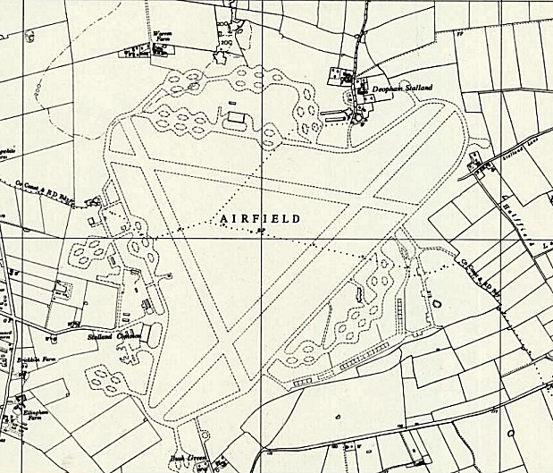
 | Ordnance Survey 1959

