Camp 268 Norduck Farm, Aston Abbotts, Buckinghamshire

1947 Camp List
268(G.W.C.) | Norduck Farm, Aston Abbotts, Aylesbury, Bucks | E | Priscamp, Aylesbury | Aston Abbotts 234 | Aylesbury | Lt.Col.S.F.Hedgecoe | v/1453/2

Prisoner of War Camps (1939 – 1948) - Project report by Roger J.C. Thomas - English Heritage 2003
OS NGR | Sheet | No. | Name & Location | County | Cond’n | Type 1945 | Comments
SP 8393 2033 | 153 | 268 | Norduck Farm, Aston Abbotts | Buckinghamshire | 4 | German Working Camp

Location: NGR site indicated on map – possibly a few huts shown nearby.  Before the camp: The Czechoslovakian President, Edvard Benĕs, lived at the Abbey in Aston Abbotts. Czechoslovakian army guards were stationed in the area to protect him, including at the site later used as a pow camp. They used tents and Nissen huts.  Pow Camp: In 1945 German POWs moved into the Nissen huts formerly occupied by Czechoslovakian soldiers and extended with tents along the drive to Norduck Farm.  The camp was raised in the House of Commons and written replies given:  “Mr. Stokes asked the Secretary of State for War how many prisoners are detained at Camp No. 268, Aston Abbotts; how many prisoners have been repatriated from that camp since the 1st October, 1946; and how many of them are at present working in industrial plants in the district.  Mr. Bellenger - On 12th February there were 1,655 prisoners of war in this Camp. 356 have been repatriated since 1st October, 1946. 797 are employed in industrial plants in the district.” (Hansard – Written answers – 18 February 1947, Vol 433).  A month later –  “Mr. Stokes asked the Secretary of State for War if he will state the names of the industrial plants near the prisoners-of-war camp at Aston Abbotts in which prisoners of war are employed, together with the number employed in each of these plants.”  The response by Mr Bellenger was given as a table: | 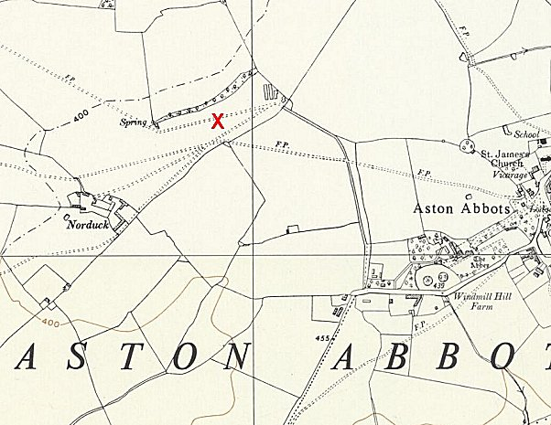
 | Ordnance Survey 1958

Calvert Brick Works (London Brick Co.) | 257
Newton Longville Brick Works (London Brick Co.) | 176
Marston Valley Brick Works | 70
Chinnor Cement Co. | 28
Crendon Concrete Co. | 10
Taylor Woodrow Co. (Turweston Airport) | 9
Smith & Sons, California Estate, Aylesbury | 62
Chittenden & Simmonds, Aylesbury | 12
Bletchley Gas Co. | 12
 | 636

(Hansard – Written answers – 8 March 1947, Vol 435).

Camp commandant c1947 Lieutenant colonel S F Hedgecoe from the Middlesex Regiment.

After the camp:
Further Information:
National Archives FO 1120/240 – Re-educational survey visit reports for camps 266 to 276. Dated 1 January 1946 – 31 December 1948

