Camp 267 Mereworth Castle Camp, Mereworth, Kent

Prisoner of War Camps (1939 – 1948) - Project report by Roger J.C. Thomas - English Heritage 2003
OS NGR | Sheet | No. | Name & Location | County | Cond’n | Type 1945 | Comments
TQ 669 532 | 188 | 267 | Mereworth Castle, Mereworth, Waterinbury | Kent | 5 | German Working Camp | Precise location not identified, NGR given for Mereworth Castle.

Location:  Before the camp: Large country house and estate.  Pow Camp:  After the camp:  Further Information: The house is privately owned.  National Archives FO 1120/240 – Re-educational survey visit reports for camps 266 to 276. Dated 1 January 1946 – 31 December 1948 | 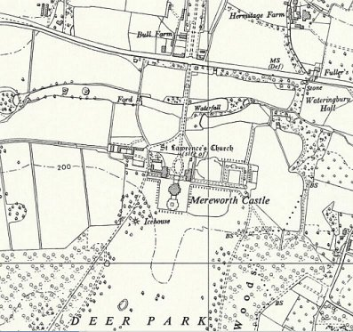
 | Ordnance Survey 1959

