**Camp 266** **Hutted Camp, Langdon Hills, Essex**

|  |  |  |  |  |  |  |  |
| --- | --- | --- | --- | --- | --- | --- | --- |
| **1947 Camp List** | | | | | | | |
| 266(G.W.C.) | Hutted Camp, Langdon Hills, Laindon, Essex | E. | Priswar, Laindon | Laindon 3334/5 | Laindon | Lt.Col.J.B.Constable | v/1453/2 |

|  |  |  |  |  |  |  |  |
| --- | --- | --- | --- | --- | --- | --- | --- |
| **Prisoner of War Camps (1939 – 1948) - Project report by Roger J.C. Thomas - English Heritage 2003** | | | | | | | |
| OS NGR | Sheet | No. | Name & Location | County | Cond’n | Type 1945 | Comments |
| TQ 668 864 | 177 | 266 | Hutted Camp, Bentley Farm, Old Church Hill, Langdon Hills | Essex | 4 | German Working Camp |  |

|  |  |
| --- | --- |
| **Location:** The NGR above places the camp inside the Parade Ground area (X) on the 1957 map. Bentley Farm is across the road from this site. It may be that the camp was by the farm with Laindon Camp used as a postal address. Local histories however, place the camp at (Y), at the end of Dry Lane, where the cricket ground was built later.  **Before the camp:**  **Pow Camp: “***The POW camp viewed from above on an October 1946 ordnance survey photograph of Langdon Hills revealed approximately 28 huts spread out in three rows*.” (Laindon History)  Reported to have opened in April 1945. Capacity stated to be 750 or 800 – it almost certainly expanded after this as the War Establishment number shows.  In 1946 German pows being transferred from camps in the US were held here. They had expected to be returned home. In April 1946, some of this group managed to hoist a swastika flag on Hitler’s birthday – however, they were not generally supported by the rest of the pows. |  |
| Ordnance Survey 1960 |

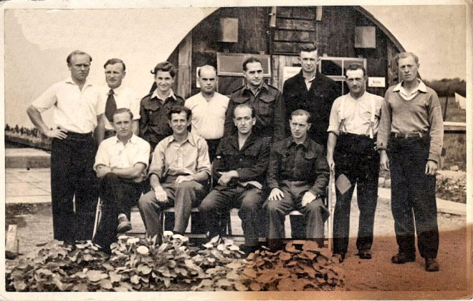

< Picture postcard sent 1946; pows and Nissen hut behind.

Camp commandant Lieutenant Colonel J B Constable

Reported to have closed July or September 1948.

**After the camp:**

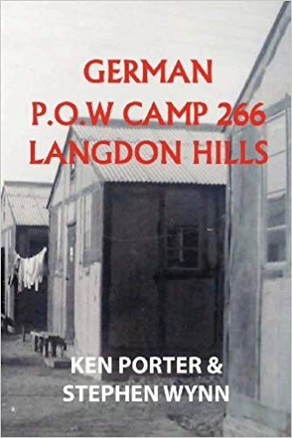**Further Information:**

National Archives -

FO 1120/240 – Re-educational survey visit reports for camps 266 to 276. Dated 1 January 1946 – 31 December 1948

HLG 91/20 – Langdon Hills prisoner-of-war camp: possible reservation for Corporation headquarters. Dated 1948.

IWM has copies of 7 news-sheets produced in Camp 266 between November 1945 to December 1947 as part of the re-education programme in the camp.

Book - German POW Camp 266 Langdon Hills – not seen by me (yet).