Camp 265 Park Farm, Thorney, Northamptonshire

Prisoner of War Camps (1939 – 1948) - Project report by Roger J.C. Thomas - English Heritage 2003
OS NGR | Sheet | No. | Name & Location | County | Cond’n | Type 1945 | Comments
TF 2925 0361 | 142 | 265 | Park Farm, Thorney, Peterborough | Northamptonshire | 4 | German Working Camp

Location: TF 289 039 where hostel located in 1958.  Before the camp: Farmland  Pow Camp: The camp was a satellite camp to Friday Bridge Camp 90, and at some time for Sawtry Camp 59 until allocated its own camp number.  (As a camp newspaper dated 1946 talks of being satellite camp 90 – and the English Heritage report lists it as being Camp 265 in 1945 - it would seem to have been camp 256 BEFORE it became a satellite camp).  Italian and later German pows.  Camp newspaper was called ‘Von Drinnen und Draussen’: Park Farm Camp Zeitung Des 90 GPWW Satellite Camp (From Inside and Outside).  After the camp: Park Farm is used as both a working farm and an exhibition and visitor centre. exhibition halls which included information on the WWII PoW Camp. Camp site is a residential area.  Further Information:  National Archives  IWM has a copy of the camp newspaper (as Camp 90) dated December, 1946. Catalogue LBY E.J. 431 | 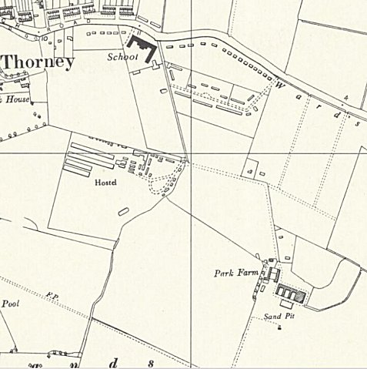
 | Ordnance Survey 1958

