Camp 258 RAF Camp, Seething, Brooke, Norfolk

Location: Seething is a small village about 9​¹⁄₂ miles south east of Norwich. RAF Seething was located S of the village. The centre of the airfield was at TM 315 955.  Before the camp: The airfield was built 1942-43 as a USAAF bomber base. It was used by the 448th Bomb Group flying B-24’s until July 1945 when it was handed over to the RAF. There were three runways and two hangars – barracks in fields to the south of the airfield.  Pow Camp: Roger Thomas (English Heritage - 2005) reported that a number of huts were hidden in nearby woodland.  A German pow, Josef Kox, recalled that in early 1946 he was; “..moved to an ex American airbase in Seething, Norfolk for a while…” (BBC People’s War website, Article A7564548).  German pows from Seething gave a concert at Bungay on 27 December 1947 – reported in the Beccles and Bungay Times  German letter-sheet June 1946.  [I think this camp was linked to the camp at Ellough Airfield (also 258) – possible a satellite camp].  After the camp: The site was sold in 1959 and mostly returned to farming land. The wartime Control Tower is a museum for the 448th Bomb group.  Further Information:  National Archives FO 1120/238 – Re-educational survey visit reports for camps 257 to 259. Dated 1 January 1946 – 31 December 1948 | 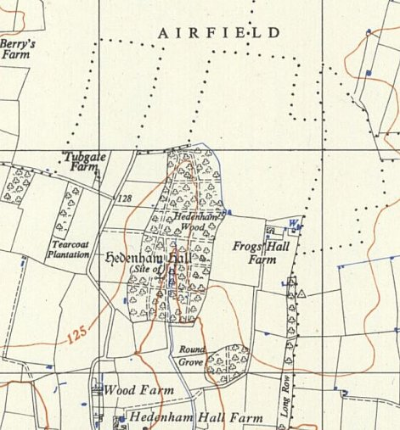
 | Ordnance Survey 1956

