Camp 258 Ellough Airfield, Beccles, Suffolk

1947 Camp List
258(G.W.C.) | Ellough Airfield, Beccles, Suffolk | E. | (Blank) | Beccles 2197 | (Blank) | Lt.Col.J.F.Ashton | v/1453/2

Prisoner of War Camps (1939 – 1948) - Project report by Roger J.C. Thomas - English Heritage 2003
OS NGR | Sheet | No. | Name & Location | County | Cond’n | Type 1945 | Comments
TM 446 853 | 156 | 258 | Ellough Airfield, Beccles | Suffolk | 3 | German Working Camp | Former RAF Beccles. NGR given for main site.

Location: The village of Ellough is about 5km SE of Beccles. The Beccles Airfield was known locally as Ellough Airfield. Based on information that the camp was alongside College Lane, I have marked a possible site at X, NGR TM 445 888.  Before the camp: The airfield was built for the USAAF in 1943-44, but was not used. The base was used by the RAF and Fleet Air Arm during 1944-45.  Pow Camp: Opened early 1946 with a capacity of 1,000. German pows and some other nationalities. The buildings on the aerodrome's Mess site, located in College Lane, were used for housing some of these prisoners, who worked as labourers in the vicinity. By the time the camp was closed in 1948 the airfield was disused.  The Foxearth and District Local History Society issued a series of news-articles from the 1947 Beccles and Bungay Times some of which featured the camp:  4 January 1947 - GERMAN PRISONERS of WAR from the camp at Ellough have been visiting Beccles. Almost every day they have been seen walking aimlessly through the streets. They require a rest room in the town.  18 January 1947 GERMAN PRISONERS of WAR: The YMCA Hut is to be opened for them on Sunday afternoons. Some of them also go to the Church Services in Beccles.  25 January 1947 - GERMAN PRISONERS of WAR passed through Beccles Station on their way to repatriation. “Some of them were standing or sitting about the platform and the rest were in the train amidst the piles of baggage and belongings. Hardly any of them spoke. Nobody smiled. They stood and sat about the platform and inside the train staring in front of them with expressionless faces. Quite honestly you would have never imagined they were on the journey home. | 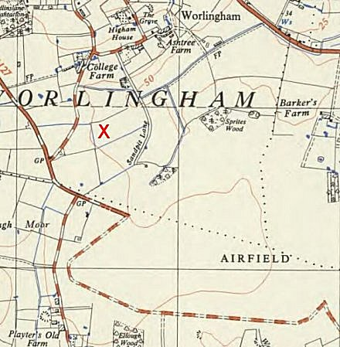
 | Ordnance Survey 1956
I was able to have a word or two with several of them and I gathered that they were under no illusions about the sort of reception they were likely to receive on their return to their “Fatherland”. Their mail comes through regularly from Germany. One prisoner, an ex-farmer from just outside Frankfurt-am-Main, said he received on an average four letters a week from his wife whom he had not seen since 1944. He was captured during the German surrender of the Channel Islands. In these letters there have been full description about the state of affairs that exist in Germany today. He had received a full report of the extent of damage this German city has received.

One cannot fail to notice the varied colours and hues of their uniforms. Various shades of green jackets are worn by Germans patrolling Beccles, often with dark brown or grey trousers, which strike a note of incongruity. However, the trousers are invariably nicely pressed and clean, so much so that you could almost cut your fingers on the crease. The glaring white letters denoting that the wearer is a German prisoner of war, seem a bit superfluous, because one could pick out a German prisoner of war a mile away with unfailing accuracy, if only because of his green uniform.
At the YMCA I was able to talk with several of them and this is what they told me. They are “browned off to the teeth” with farm life in Suffolk, with eternal cutting and chopping of sugar beet and more and more sugar beet, they want to get home to the “heimat” as quickly as possible in spite of everything; they want to live in the British Zone in preference to any other; they think there won’t be any more war in Europe anyway, because of the atomic bomb. One of them was careful to explain to me what had happened to Japan. Pictures of the damage caused by the atomic bombs in Japan had been circulated in all countries. These pictures had shown that atomic bombs burned up everything and killed every form of organic life. That in short, would “put the wind up” all warmongers and aggressors in future.

Not a single one of them mentioned the words “National Socialism” or “Adolf Hitler”. One of them did make a plea on behalf of his own country. He said that Germany must have a place in the world’s social order of things. Germany had produced great scientists, musicians, writers, doctors and could produce plenty of coal, steel, machines etc, for which the world was crying out today.
There was one trace of perhaps unconscious humour. He had been watching Beccles Town football team getting their weekly hiding on College Meadow, and so he said to me, “Our camp team could beat Beccles Town team easily!” Of course, they have no money to spend as we know money. Instead they are issued with camp vouchers. I saw one of these vouchers. It was marked “WD., One Shilling.” with the name and date stamp of the camp marked thereon.

1 February 1947 - GERMAN PRISONERS of WAR: One aged over 40 is a Yugoslavian, who lived about 50 miles from Belgrade. When the Germans occupied his country he was forced on pain of death to join up and fight for Hitler. Now he is afraid to return home because he thinks the present regime will exact retribution for having “assisted the enemy” and will be arrested the moment he sets foot in his native country. He never hears from his wife and family, who may think he is dead.

8 February 1947 - SNOW: It costs £200 a day to clear the snow in East Suffolk. By Monday they had 300 Prisoners of War at work, 250 from the Ministry of Transport, 20 from contractors, 10 from Catchment Board, 70 boys from Shotley Naval School and 530 County Council men.

15 February 1947 - BECCLES CHORAL SOCIETY sang excerpts from the Messiah in the YMCA hut, conducted by Mr RH Firth. Miss Mary Odam gave a selection of Soprano passages, Mr Lloyd Smith was the accompanist. Many Prisoners of War from the Ellough Camp attended.

3 May 1947 - FOUR GERMAN PRISONERS of WAR escaped from a lorry taking them to work from the Camp at Ellough. They were later arrested at Homersfield.

Camp commandant c1947 Lieutenant Colonel John Forbes Ashton, from the Border Regiment. He moved in late 1947 to Camp 186 Fornham.
[I believe camp 258 at Seething was linked to this camp].
After the camp: A smaller airfield site was opened in 1965. Other parts used for Ellough Industrial Estate.
Further Information:
National Archives FO 1120/238 – Re-educational survey visit reports for camps 257 to 259. Dated 1 January 1946 – 31 December 1948

