Camp 257 Pennygillam Farm Camp, Launceston, Cornwall

1947 Camp List
257(G.W.C.) | Penygillam Farm Camp, Launceston, Cornwall. | S. | Priswar, Launceston | Launceston 433 | Launceston | Lt.Col.W.G.Petherick | v/1453/2

Prisoner of War Camps (1939 – 1948) - Project report by Roger J.C. Thomas - English Heritage 2003
OS NGR | Sheet | No. | Name & Location | County | Cond’n | Type 1945 | Comments
SX 320 836 | 201 | 257 | Pennygillam Farm Camp, Launceston | Cornwall | 4 | German Working Camp | Site occupied by an industrial estate

Location: Recorded as being on the site where the school was built at NGR SX 324 837. Another camp was located very close at Scarne, Launceston.  Before the camp: Farm belonging to George Robbins. US army used the site up to D-day. Mainly tented with some huts being built  Pow Camp: ICRC report below stated Tarrant huts in use. The picture taken at the entrance to the camp just after it had become a ‘hostel’ for agricultural workers shows Tarrant type huts. German pows. (1 philatelic item has a letter from an Italian pow – Italians may have been billeted and attached to the camp, or may have been part of a workforce that was often use to build the camps?)  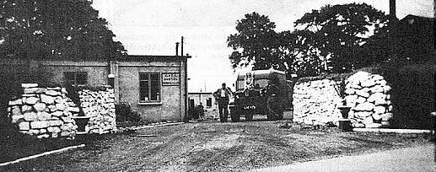  The camp was inspected by the International Red Cross in November 1945 – report below.  Camp commandant c1945 Major Frederick Henry Bawden, OBE. 1890 – 1946. He gained his OBE while serving with the Labour Corps in France. As commandant he was serving with the Pioneer Corps. He may have died while serving as he died on 16 November 1946. He is recorded on the war memorial at Camborne, Cornwall. | 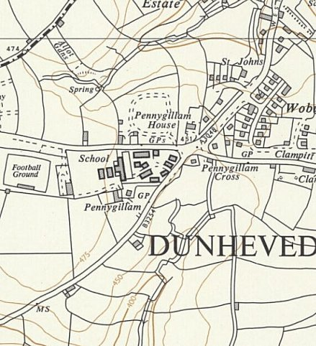
 | Ordnance Survey 1963

Camp commandant c1947 Lieutenant Colonel W G Petherick, from the 3rd King’s Own Hussars.
Philatelic items:
1946 Italian letter-sheet and German letter-sheet 14 Juli 1946

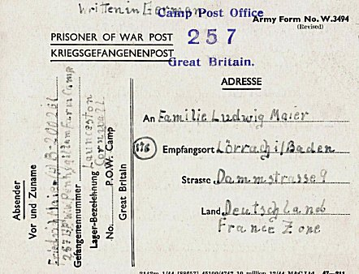
< Pow postcard dated 8/1/1947. German letter-sheet 8 May 1947
After the camp: Camp used as a ‘Harvest camp’ to accommodate agricultural labour. Late 1950’s secondary modern school built on the site. 2020 industrial estate.
Further Information:
National Archives FO 1120/238 – Re-educational survey visit reports for camps 257 to 259. Dated 1 January 1946 – 31 December 1948

H/JRh/NG.  Great Britain  Working Company 257  Visited in November 1945 by M. Haceius -  Postal Address : 257 German Working Company, Gt.Britain  Commandant : Major F.H. BAWDEN, OBE.  Camp leaders : FELDMANN Ernst "Obfkm."  KORNACKER Peter "Fwb."  BECKMANN Hans "Fwb."  NIESE Ernst WE. BEAMT  Numbers : 488 German prisoners, including 1 officer doctor.  General comments  This camp is located on a dry, sloping ground. The prisoners are mainly in "Tarrant" huts which are in good condition; 120 men are still in tents. The huts are lit by electricity and heated from 5 p.m., but the tents are not heated. Each tent shelters 6 men sleeping in bunk beds, equipped with straw mattress and with three blankets each. The tents are on dry ground. The camp includes only one hut-refectory of 120 places and meals have to be served in four sessions.  We have raised with the responsible authorities the fact that the tents do not have lighting.  Sanitary facilities  The latrines are well maintained and sufficient in number.  Food  Prisoners regularly receive the official rations with three meals per day, (the main meal is served in the evening). An oven has just been built and 6 bakers currently work using what they can.  The prisoners have a ration of bread (19 oz. - 580 gm) on four days; for the three other days, the ration of bread is replaced by 12 oz. of biscuits. 7½ oz of biscuits replace 10 oz. of bread, as stated in the regulation 53/general/7235 of May 28, 1945, fixing the rations for prisoners in Great Britain.  Medical care  The senior doctor, Joachim WIEDEMANN, and 4 members of the medical team are responsible for any patients. Currently, five, slightly sick prisoners, are receiving treatment in the infirmary and one at the hospital. The supplies are sufficient.  Clothing  60% of the prisoners have not had to use a replacement uniform, nor the winter underwear. The prisoners assigned to drainage work carry wellingtons. |  | Work  The prisoners are involved with agricultural work and drainage; 382 were working on the day of the visit.  Canteen  For some time, the canteen has been better supplied.  Recreation  No courses have been organised and the prisoners do not have books.  Some musical instruments and a piano will be bought thanks to the “Welfare Fund".  The camp has a radio. A cinema presentation takes place each month. Several teams of prisoners practise football.  Correspondence  The prisoners dispatched 270 cards approximately five weeks ago and received 120 answers from the British zone, 2 from the American zone and 3 from the French zone.  They alternatively write a card and a letter each week to maintain communications with their family.  Preparations for winter  Floors have been installed in the tents, but none are equipped with a double roof.  The prisoners are to receive a fifth blanket.  No lighting has been installed in the tents.  There will be sufficient places available in the heated refectories so that the prisoners in the tents can pass the evening there.  Requests by “Obfkm” Ernest FELDMANN :  1) Erection of a second hut-refectory.  2) Library (text books and novels).  3) Providing 30 hoods to prisoners who do not have them  4) Lighting for the tents.  Conclusion  This camp is well managed and, apart from the points raised by the camp leader, we had no complaints to record.  (Translated by M Sanders 2010)

