Camp 255 RAF Camp, Snettisham, Norfolk

Prisoner of War Camps (1939 – 1948) - Project report by Roger J.C. Thomas - English Heritage 2003
OS NGR | Sheet | No. | Name & Location | County | Cond’n | Type 1945 | Comments
TF 647 333 | 132 | 255 | RAF Camp, Snettisham Scalp, Snettisham | Norfolk | 3 | German Working Camp | Camp associated with an RAF later USAAF gunnery range

Location: The site is about 4 km SW of Snettisham.  Before the camp: Area used as RAF Gunnery range. During 1943 the site used by USAF as gunnery training site for B-17 crews.  Pow Camp: A main camp and various requisitioned bungalows and holiday homes along the front.  After the camp: Although no longer a pow camp the site was held by the Government until 1948. This was raised in parliament:  “Major Wise asked the Minister of Works on what date the prisoner of war camp at Snettisham will be handed over for derequisitioning and will he take all possible steps to make this date as early as possible in order that the owners of the beach bungalows now within the area of the camp may once again be able to occupy their properties for summer holiday purposes.  Mr. Key - Snettisham Camp itself is to be retained for Government use, but I hope that the beach bungalows will be derequisitioned within about a month. Arrangements for individual owners of bungalows to occupy their property in ​ advance of formal derequisitioning will be made on application to my Regional Compensation Surveyor, Cambridge.” (Written replies, House of Commons, 29 June 1948, Vol 452).  2020 – main site holiday homes and caravans, wider area a large RSPB site.  Further Information:  National Archives FO 1120/237 – Re-educational survey visit reports for camps 252 to 256. Dated 1 January 1946 – 31 December 1948 | 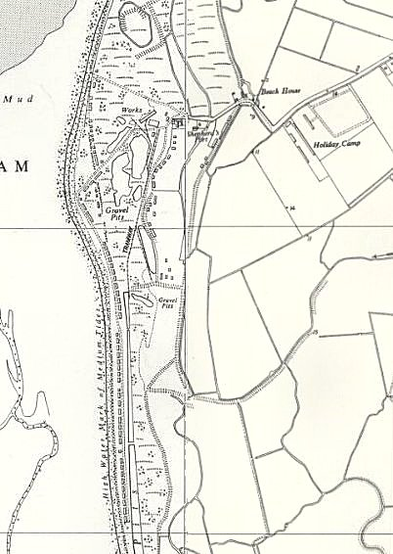
 | Ordnance Survey 1958

Photographs taken 1947 / 1948 by a German pow of the camp at Snettisham - www.facebook.com/snettishamROW / Google
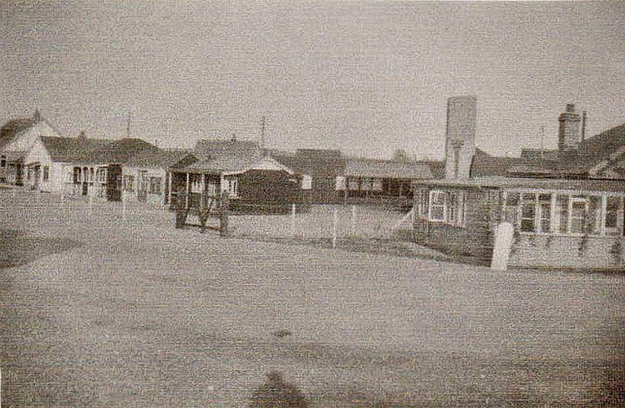 |  | 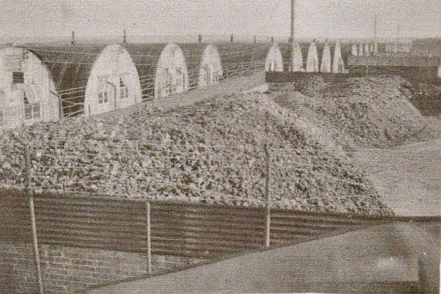 |  | 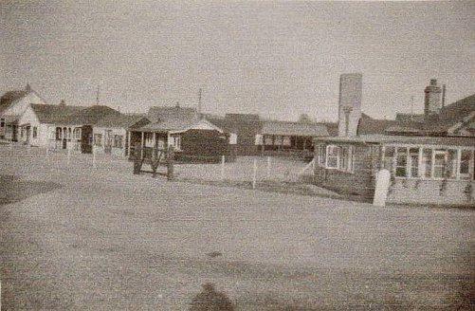
Hűtten 1 - 12 |  | Hűtten 15 - 40 |  | Vorderansicht / Front view
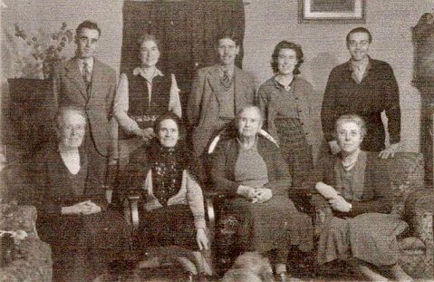 |  | 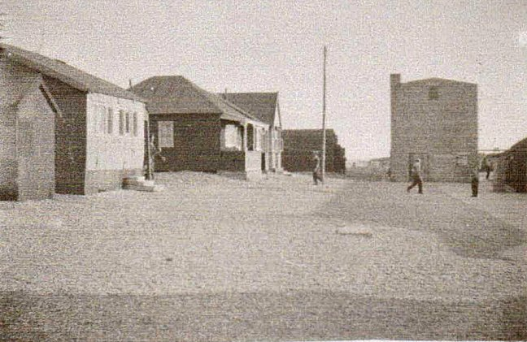 |  | 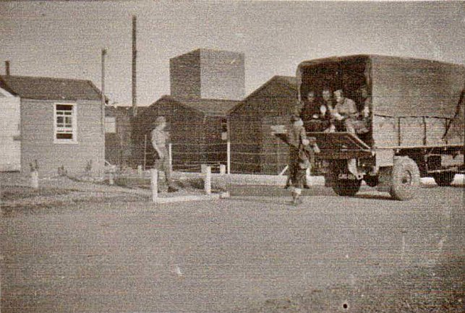
Hausmusik in Heacham – Upper R Edmund Meiser, pow choirmaster |  | - |  | -
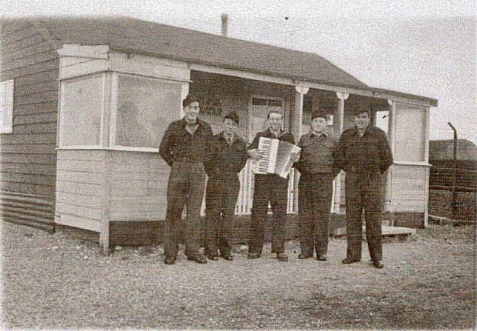 |  | 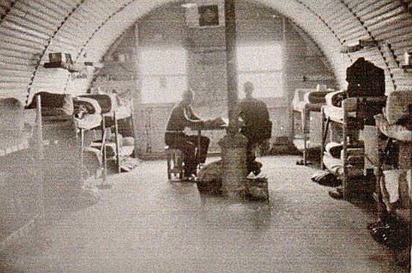 |  | 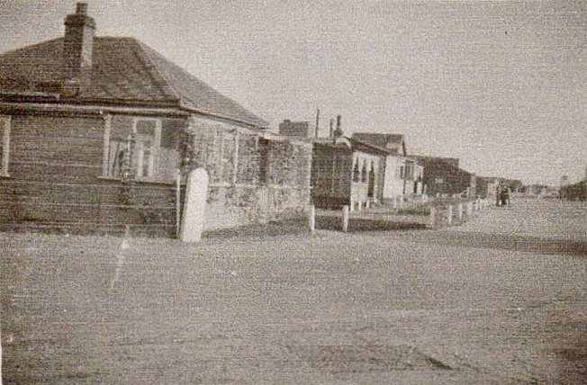
Chor und Theaterbungalow – Choir and theatre |  | Unsere Barracke – Our barrack |  | -

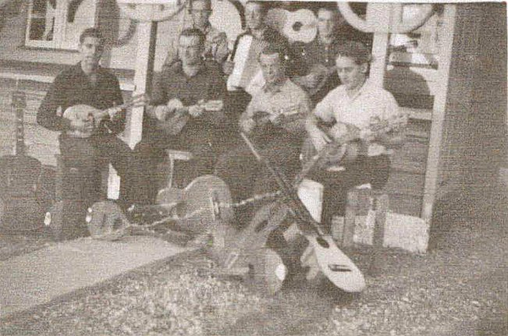 |  | 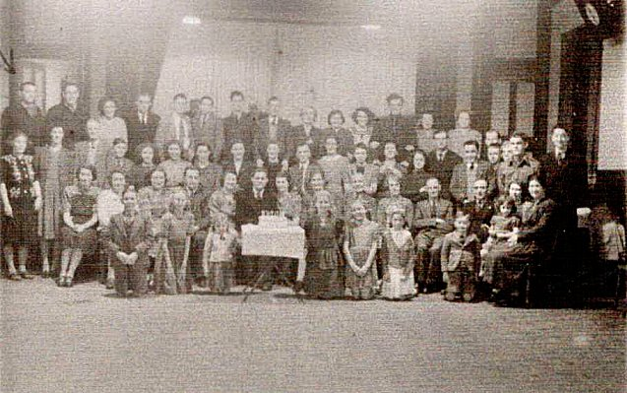 |  | 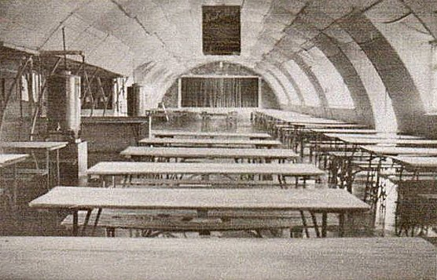
Das Chor – orchester – oben mitte chorleiter Edmund Meiser / The choir – orchestra – top middle the choir leader Edmund Meiser |  | Hier Heacham - Geburtstagfeier (?), als Gast: links oben Edmund Meiser (Chorleiter der POW) /  At Heacham - Birthday party (?). as a guest: top left Edmund Meiser (choir leader of the POW). |  | Speisesaal – diningbarrack / Meal room

