**Camp 25****3 Mousehold Heath Camp, Norwich, Norfolk**

|  |  |  |  |  |  |  |  |
| --- | --- | --- | --- | --- | --- | --- | --- |
| **1947 Camp List** | | | | | | | |
| 253(G.W.C.) | Mousehold Heath Camp, Norwich, Norfolk | E. | Priswar, Norwich | Norwich 20461/2 | Norwich | Lt.Col.J.B.V.Phillips | v/1453/2 |

|  |  |  |  |  |  |  |  |
| --- | --- | --- | --- | --- | --- | --- | --- |
| **Prisoner of War Camps (1939 – 1948) - Project report by Roger J.C. Thomas - English Heritage 2003** | | | | | | | |
| OS NGR | Sheet | No. | Name & Location | County | Cond’n | Type 1945 | Comments |
| TG 245 105 | 134 | 253 | Mousehold Heath Camp, Norwich | Norfolk | 5 | German Working Camp | Possible site may still exist on north western side of parkland |

|  |  |
| --- | --- |
| **Location:** Mousehold Heath lies to the NE of Norwich. The NGR from the English Heritage report is shown at X. However, the camp was identified at A / B by the Gravel Pit.  **Before the camp:** Gravel pit. Some previous military use.  **Pow Camp:** *“The main body of the camp is visible by February 1946 (S5) comprising at least 21 Nissen huts of varying lengths and several ancillary buildings, centred on TG 2506 1015. By the following month five rows of tents are visible to the north (S6), centred on TG 2504 1023 as temporary accommodation, for what later becomes an expanded camp (S7) with three rows of (at least a further 24) Nissen huts centred on TG 2504 1023 with pitched roofs, and the camp master’s house visible to the south at TG 2510 1019. Each of these changes has been mapped as a separate extent of area within the site.*  *Some of the structures related to the camp are still visible on later photographs (S8), but the site had been converted to sports fields by 1988 (S9).”*  [www.heritage.norfolk.gov.uk/record-details?MNF57545](http://www.heritage.norfolk.gov.uk/record-details?MNF57545) (Sources below).  Pows were invited to visit local residents’ homes for Christmas 1947. ‘*I accept with pleasure your kind invitation for Christmas day*’ - these were the words of pow Hans Dittrich written to a Mrs K Stalham on December 20 1947 on a letter held in Norfolk Record Office.  Camp commandant c1947 Lieutenant colonel J B V Phillips |  |
| Ordnance Survey 1956 |

**After the camp:**

**Further Information:**

National Archives FO 1120/237 – Re-educational survey visit reports for camps 252 to 256. Dated 1 January 1946 – 31 December 1948

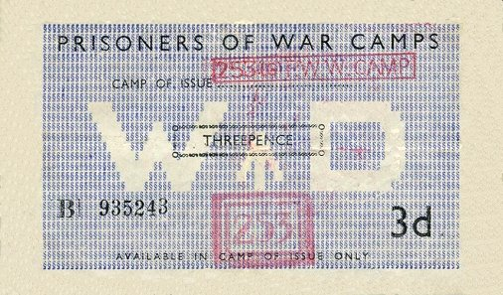

|  |  |
| --- | --- |
| <S5> | Vertical Aerial Photograph: RAF. 1946. RAF 3G/TUD/UK/70 5029-30 28-FEB-1946 (NMR). **A** |
| <S6> | Vertical Aerial Photograph: RAF. 1946. RAF 106G/UK/1254 6062 20-MAR-1946 (NMR). **B** |
| <S7> | Vertical Aerial Photograph: RAF. 1947. RAF CPE/UK/2019 5134-5 18-APR-1947 (NMR). **B** |
| <S8> | Vertical Aerial Photograph: RAF. 1951. RAF 58/767 (Vp1) 5088 29-JUL-1951 (NMR). |
| <S9> | Vertical Aerial Photograph: BKS. 1988. BKS 9855 06-AUG-1988 (NCC 1433). |

< Token money that could be used by the pows only at the detailed camp. The back was date stamped each time it was used.