Camp 252 Abergwili Hospital, Carmarthen, Carmarthenshire

1947 Camp List
252(Hospital) | P.W.Military Hospital, Abergwili, Carmarthen | W | Priswar, Abergwili | Carmarthen 7433 | Carmarthen | Major V.G.Matthews | v/1395/2

Prisoner of War Camps (1939 – 1948) - Project report by Roger J.C. Thomas - English Heritage 2003
OS NGR | Sheet | No. | Name & Location | County | Cond’n | Type 1945 | Comments
 |  | 252 | Abergwili Hospital, Abergwili, Carmarthen | Carmarthenshire |  |  | Wales

Location: NGR SN 4286 2130  Before the camp: Temporary hospital site for the US Army up to 1944 in the grounds of the main hospital.  Pow Camp:  The camp was inspected by the International Red Cross on 13 November 1945 – report below.  The camp was visited on 21 October, 1946 by Paul Bondy to give a lecture as part of the re-education programme for pows. It was recorded that 450 pows attended.  Camp commandant c1947 Major V G Matthews, (possibly from the Leicestershire Regiment).  After the camp:  Further Information:  National Archives FO 1120/237 – Re-educational survey visit reports for camps 252 to 256. Dated 1 January 1946 – 31 December 1948 | 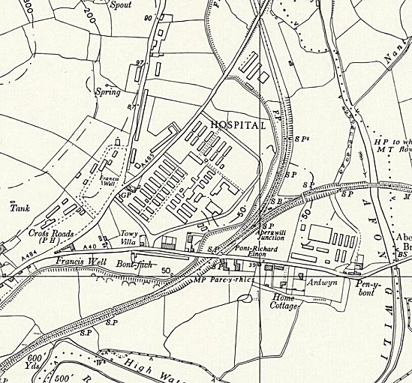
 | Ordnance Survey 1964

Great Britain
Military Hospital for Prisoners of War 252
Visited on 13 November, 1945 by M.Chavan

Address : Military 252 P.W. Hospital

Commander : Major HUBER

Camp leader : ARNOLD Fritz "Oberfeldarzt"

British officer doctor : Lt. Col, J.D, Cruickshank

German doctor : Prof. RODENWALDT. Ernst "Generalarzt"

Capacity : 750 men

Actual strength : 400 German prisoners, made up from; 18 officer doctors, 207 assistants, 175 patients.

No change has occurred since the arrival in this hospital of "Generalarzt" Prof. E. RODENWALDT and the increase in the number of the patients (175 instead of 93 on our preceding visit) come mainly from collecting sick prisoners from other work camps, (84 of them will be repatriated soon). The camp leader had no complaints. Food is sufficient and of good quality.

Money and pay : All of the medical personnel are recognized and thus receive wages.

Canteen : The canteen is well organized. The prisoners are entitled to 40 cigarettes per week.

Religious services :

Currently, a protestant chaplain from camp 199 [Haverfordwest] comes to read a service each week, and a civil catholic priest comes each week.

Correspondence : One hundred cards have arrived from the British zone, but at this time none from the American and French zones.

Two deaths have occurred during the last few months.

Conclusion

This hospital provides an excellent impression. The moral of the patients is good and each one is happy to think that he will be repatriated soon.

(Translated by M Sanders 2010)

Lieutenant Colonel J D Cruickshank was from the Royal Army Medical Corps.

