Camp 251 East Cams Camp, Portchester Road, Fareham, Hampshire

Included in the 1945 ICRC Camp list – Labour Camp.251. East Cams Camp, Portchester Rd, Fareham, Hants.

1947 Camp List
251(G.W.C.) | East Cams Camp, Portchester Road, Fareham, Hants | E. | Priswar, Fareham | Fareham 2566 | Fareham | Lt.Col.St.J.Hartley | v/1453/2
Name crossed out and changed to: |  |  |  |  |  | N.C.H.Downe

Prisoner of War Camps (1939 – 1948) - Project report by Roger J.C. Thomas - English Heritage 2003
OS NGR | Sheet | No. | Name & Location | County | Cond’n | Type 1945 | Comments
SU 5985 0616 | 196 | 251 | East Cams Camp, Portchester Road, Fareham | Hampshire | 4 | German Working Camp | Site occupied by housing, the roads (The Thicket & The Spinney) observe the routes of the camp roads.

Location: Just off the A27 Portchester Road  Before the camp:  Pow Camp: “East Cams Estate had apparently been built between 1943 and 1944 to house workmen employed locally, building sections for the Mulberry Harbour… After the men had completed the task and left, prisoners-of-war were moved into the huts for the remainder of the war. After cessation of hostilities in 1945 the local authority – Fareham Urban District Council – took the camp over, renamed it East Cams Estate, and used it for temporary accommodation…. It had been a typical military-style camp with a collection of corrugated tin nissen huts, interspersed here and there by wooden huts and ablution blocks.” (From Fareham Revisited).  Camp commandant c1947 Lieutenant Colonel St J Hartley  Camp commandant c1947 Lieutenant Colonel N C H Downe, formerly from the Royal Regiment of Artillery – transferred during 1947 from Camp 41 to Camp 251 East Cams Camp.  After the camp:  Further Information:  National Archives FO 1120/236 – Re-educational survey visit reports for camps 247 to 251. Dated 1 January 1946 – 31 December 1948  ‘Fareham Revisited’ by Michael Stephenson – 2015, Andrews UK Ltd. | 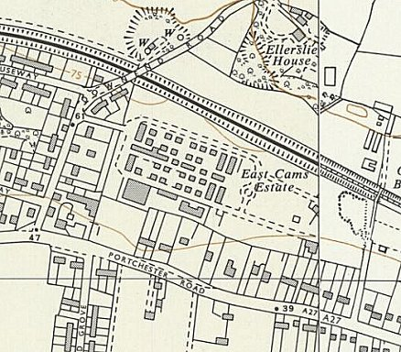
 | Ordnance Survey 1963

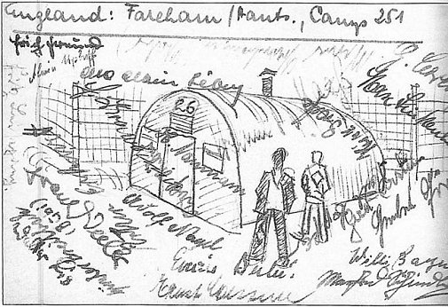 | 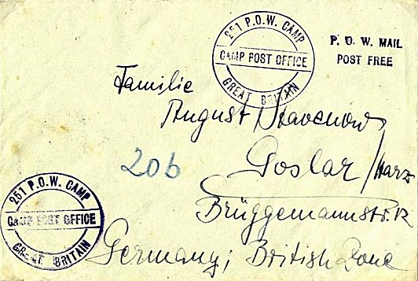
https://www.dayofarchaeology.com/oral-history-at-a-pow-camp-in-hampshire/  From:L. Burton and B. Musselwhite, 2006 the Book of Fareham Halsgrove, Tiverton. | Envelope sent from Camp 251 – arriving on 23 January 1948. Illustrated in the Forces Postal History Society Journal, Number 299, Spring 2014, Vol XXX, No5

