Camp 248 Norton Camp, Cinderhill Lane, Norton, Yorkshire

1947 Camp List
248(G.W.C.) | Norton Camp, Cinderhill Lane, Norton, Sheffield | N. | Priscamp, Sheffield | Woodseats 45901/2 | (Blank) | Lt.Col. V.C.Holland | v/1453/2

Prisoner of War Camps (1939 – 1948) - Project report by Roger J.C. Thomas - English Heritage 2003
OS NGR | Sheet | No. | Name & Location | County | Cond’n | Type 1945 | Comments
SK 3625 8175 | 111 | 248 | Norton Camp, Cinderhill Lane, Norton, Sheffield | Yorkshire | 5 | German  Working Camp | Precise location not identified, NGR given for approx feature centre of Cinderhill Lane.

Location: (Note there was another camp called Norton Park – 174 in Nottinghamshire). Wartime memories confirm the camp was on Cinderhill Lane, but not an exact location, other than ‘next to a farm’. Looking at earlier OS maps there are no farms on the N side of the lane – and the only farm on the S side is shown on the 1956 map just above the 2nd letter R of Jordanthorpe.  Before the camp: Farmland  Pow Camp:  An inspection of the camp was carried out by the International Red Cross on 20 February 1947.  A programme for a puppet theatre at the camp was sold in 2018.  Camp commandant c1947 Lieutenant Colonel V C Holland.  After the camp:  Further Information:  National Archives FO 1120/236 – Re-educational survey visit reports for camps 247 to 251. Dated 1 January 1946 – 31 December 1948 | 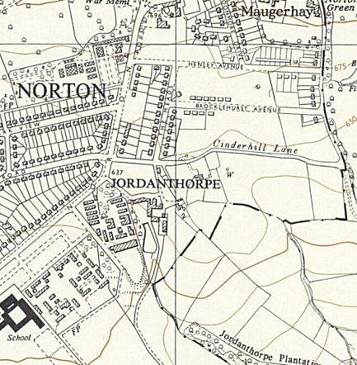
 | Ordnance Survey 1956

