Camp 248 New Drill Hall, Clay Cross, Derbyshire

Prisoner of War Camps (1939 – 1948) - Project report by Roger J.C. Thomas - English Heritage 2003
OS NGR | Sheet | No. | Name & Location | County | Cond’n | Type 1945 | Comments
SK 390 640 | 119 | 248 | New Drill Hall, Clay Cross | Derbyshire | 4 |  | Site Occupied by industrial estate.

Location:  Before the camp:  Pow Camp:  After the camp:  Further Information:  National Archives FO 1120/236 – Re-educational survey visit reports for camps 247 to 251. Dated 1 January 1946 – 31 December 1948 | 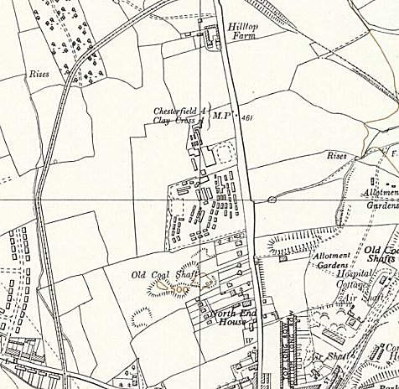
 | Ordnance Survey 1955

