Camp 246 North Camp, Nettlebed, Henley-on-Thames, Oxfordshire

Prisoner of War Camps (1939 – 1948) - Project report by Roger J.C. Thomas - English Heritage 2003
OS NGR | Sheet | No. | Name & Location | County | Cond’n | Type 1945 | Comments
SU 7046 8675 | 175 | 246 | North Camp, Nettlebed, Henley-on-Thames | Oxfordshire | 4 | German Working Camp

Location: Just to the E of Nettlebed.  Before the camp: North camp site was farmland. US troops built the N and S camps. The United States Corps of Engineers built sewerage and water treatment plants, one of which remains and is used by Nettlebed village today.  Pow Camp: Only the North camp is listed as a pow camp. Q if this was a satellite camp to Camp 246 at Basildon House.  After the camp: Both camps were used by the Polish Resettlement Corps - confirmed by entry in Hansard, House of Commons, 25 February 1947, Vol 433.  Further Information:  National Archives FO 1120/235 – Re-educational survey visit reports for camps 240 to 246. Dated 1 Jan 1946 – 31 Dec 1948 | 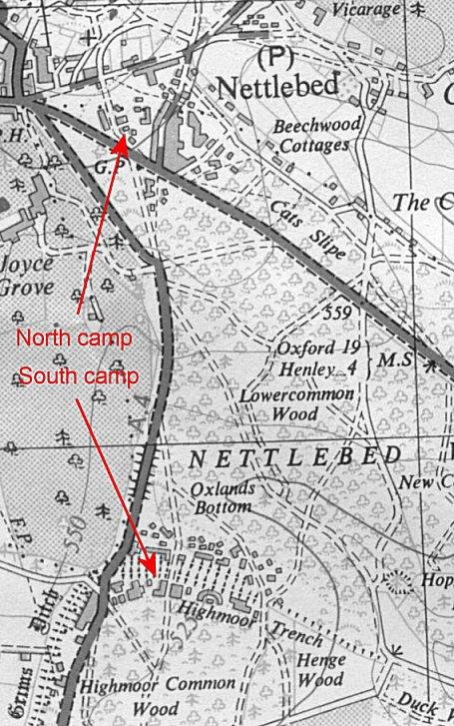
 | Ordnance Survey 1948

