Camp 244 Butterwick Camp, Malton, Yorkshire

Prisoner of War Camps (1939 – 1948) - Project report by Roger J.C. Thomas - English Heritage 2003
OS NGR | Sheet | No. | Name & Location | County | Cond’n | Type 1945 | Comments
SE 731 775 | 101 | 244 | Butterwick Camp, Malton | Yorkshire | 5 | German Working Camp | Precise location not identified, NGR given for centre of village.

Location: NOTE there were two BUTTERWICK camps in Yorkshire, this one and Camp 159. They are about 25 km apart.  Before the camp: Farmland  Pow Camp:  At some point in 1944, Russian (Soviet) pows were moved to this camp; “The first serious trouble on this score arose at Butterwick Camp, near Malton in Yorkshire. There were several hundred “Russians”, transferred from transit camps in the south. They spoke a multiplicity of tongues, for amongst them were men of races as diverse as Georgians, Turkestani and Tartar; there were even bemused Tajik tribesmen from the Pamirs.” ( * )  At this time the Russians were unsure as to their fate. A great many had been forced to work as slave labour, but there were also some who had fought willingly for the Germans.  There was a realisation that they would most likely be treated harshly on their return to the Soviet Union, where surrender was regarded almost as seriously as treason. Some, fearing the worst, stated that they did not wish to return. Other pows stated that they did wish to return to their homelands, but wanted to meet with Soviet delegates in the UK first, in order to state that they had been forced to work by the Germans and now wished to be repatriated, even to return to the fight against Nazism, as loyal Soviet citizens.  One of the first groups of Russians arriving at the camp refused to get off the transport trucks because; “A group of curious British staff officers, who had driven over to witness the Russians’ arrival, had been taken for officers of the NKVD sent to supervise a massacre of the prisoners”. ( * ) They were soon re-assured this was not the case, but it shows how the pows were fearful of what the Soviet authorities had planned for them. | 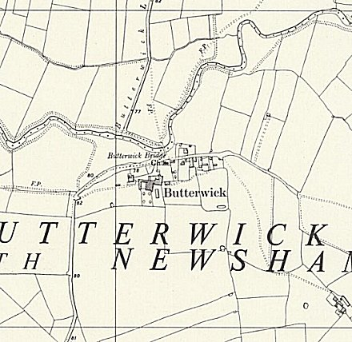
 | Ordnance Survey

Amongst these pows were some ‘youth’ pows (under-21) and a ‘sizeable’ group from the Organisation Todt pow camp on Alderney, where conditions had been appalling.
When Soviet delegates failed to appear; “ a group of about 550 of the Butterwick inmates became increasingly restive.” ( * ) On 30 August they raised a petition believing the British were responsible by not allowing Soviet delegates to visit. Shortly after, they staged a strike against having to wear pow uniforms, arguing that it was insulting as they were not pows because they had been forced into working as slaves for the Germans. For their action they were placed on punishment rations – despite this, many continued with the strike, though they did wear the pow uniforms.
On 4 September 1944, the British cabinet decided; “…that we should agree to the Soviet Government’s request to repatriate their prisoners from the United Kingdom;” (War Cabinet conclusions, 4 September 1944, 115(44)) – this was later confirmed at the Yalta Conference in February 1945.
On 8 September 1944, representatives of the Soviet Military Mission to the UK led by Major-General Vasiliev visited Butterwick for two days where there were 3000 Russian pows. Despite giving reassurances that all returning Soviets would be treated fairly, the representatives had a mixed reception and some pows were openly hostile. Amongst the pows were ex-members of the Russian Liberation Army, (Russkaya Osvoboditel’nya Armiya – abbreviated to POA or Anglicized ROA) – a formation that fought for the Germans, and who had every reason to be fearful if they were returned to the Soviet Union. It appears that the message of their likely return was disclosed to the pows as on the second day many of the ex-ROA had removed their badges. The Soviet representatives moved on to visit Catterick Camp, where they continued their pretence that all would be dealt with fairly.
The first shipment of Soviet pows back to Russia took place at the end of October – many from Butterwick – many were executed or imprisoned in the Soviet Union.
After the camp: Farmland
Further Information:
National Archives FO 1120/235 – Re-educational survey visit reports for camps 240 to 246. Dated 1 Jan 1946 – 31 Dec 1948
*Victims of Yalta – Nikolai Tolstoy, Hodder and Stoughton, 1977. Some inaccuracies have been recorded against this book.

