Camp 240 (& 285) Hawkstone Park, Weston, Shropshire

1947 Camp List
240(G.W.C.) | Hawkstone Park, Weston Shrewsbury, Shropshire | W. | Priswar, Wem | Wem 127/8 | (Blank) | Major G.T.W. Collins | v/1452/2

Prisoner of War Camps (1939 – 1948) - Project report by Roger J.C. Thomas - English Heritage 2003
OS NGR | Sheet | No. | Name & Location | County | Cond’n | Type 1945 | Comments
SJ 567 288 | 126 | 240 | Hawkstone Park, Weston | Shropshire | 4 | German Working Camp | Site occupied by a golfcourse. See Camp no.285
 |  | 285

Location: Site of NGR marked X, however Hawkstone Park is further to the NE. The present-day golf course is located between Hawkstone Hotel and Red Castle.  Before the camp:  Pow Camp: It was co-located with the US Army Disciplinary Training Centre No 7 (aka Western Base Section Guardhouse), who may have provided the guards (until when?). The US detachment was commanded by Captain L E Davidson. The 1947 commandant is a British officer.  The camp was in use up until 1948.  Camp commandant c1947 Major G.T.W. Collins, from the Royal Warwickshire Regiment.  Postal items: POW letter-sheet 14 March 1948 in German to Germany.  After the camp: HER records it as being a golf course  Further Information:  National Archives FO 1120/235 – Re-educational survey visit reports for camps 240 to 246. Dated 1 Jan 1946 – 31 Dec 1948 | 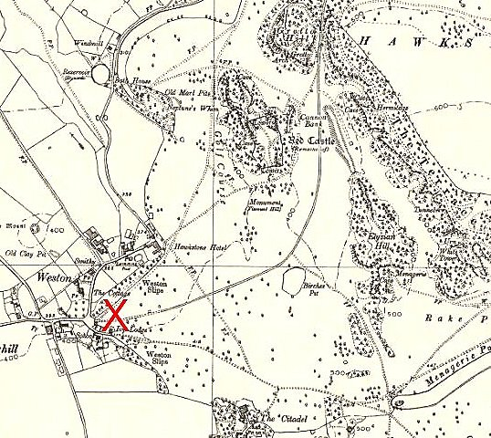
 | Ordnance Survey 1957

