Camp 239 Weston Acres Camp, Woodmansterne, Surrey (aka Banstead)

Included in the 1945 ICRC camp list – Labour Camp.239. Westonacres, Woodmanstone, Banstead, Surrey.

1947 Camp list
239(G.W.C.) | Weston Acres, Woodmansterne, Banstead, Surrey | L.D. | Priswar, Banstead | Burgh Heath 3981 | Banstead | Lt.Col.H.St.G.Thoyts, M.C. | v/1453/2
The entry above has been crossed out in blue crayon and the following details handwritten on.
 | Shirley Church Road, Addington, Croydon, Surrey |  | Croydon | Spring Park 2296/7 | East Croyden | R.H. McGeorge

Prisoner of War Camps (1939 – 1948) - Project report by Roger J.C. Thomas - English Heritage 2003
OS NGR | Sheet | No. | Name & Location | County | Cond’n | Type 1945 | Comments
TQ 265 585 | 187 | 239 | Westonacres Camp, Woodmansterne, Banstead | Surrey | 2 | German Working Camp | Two possible sites, other possibility is at TQ 265 595

Location: The main site was located at Park Farm on the Banstead Wood Estate. The farm is NGR TQ 266 573. Weston Acres on Woodmansterne Lane was the postal address and command centre used for the main and satellite camps and was located at NGR TQ 272 600 to the N of the Park Farm site.  Before the camp: Farmland and open woodland. The local area had Canadian troops from 1940 to July 1944.  Pow Camp: The main buildings were located around the Park Farm buildings. Tented accommodation and some Nissen and wooden huts. The camp was surrounded by a barbed wire fence, but reports talk of limited guard numbers.  There are records of 150 Italian pows from 1944 to 1946, and then German pows. However, the camp is recorded in the English Heritage above to be a German Working camp in 1945 – the Italian pows may have been allocated to hostels once the Germans arrived.  German pows being returned from America, and expecting to be returned to Germany, were held here.  Satellite camps / hostels identified from pow mail at  Elm Road, Chessington  Long Ditton  Billet Road, Staines  Laleham Road, Staines  Claygate Lane, Thames Ditton  Whitton  Camp commandant c1947 Lieutenant Colonel H St.G Thoyts, M.C. from the Lincolnshire Regiment.  The camp closed in 1947, (the camp number was then re-allocated to the Shirley Church Road site). | 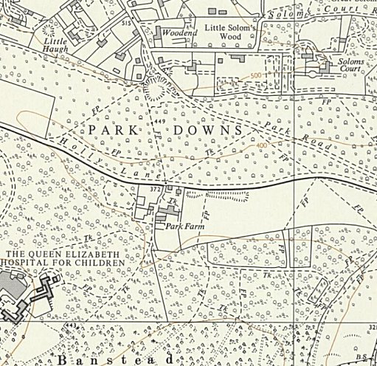
 | Ordnance Survey

After the camp: The woodland was re-opened to the public in April 1947. Park Farm was used as a scout campsite. 2020 Weston Acres is a retirement home

Further Information

National Archives FO 1120/234 – Re-educational survey visit reports for camps 236 to 239. Dated 1 Jan 1946 to 31 Dec 1948

Two articles about the camp and postal history – Forces Postal History Society, No 291, Spring 2012, by Peter High; and No 294, Winter 2012, by Peter Burrows.

World War II: The Banstead Wood Camp – John Sweetman, Banstead History Research Group, 1995

IWM – Private papers of Captain F Hilton. Felix Hilton was an agent of the SOE operating behind-the-lines in France and Belgium from 12 June 1944. Diary notes cover his time as an interpreter at Weston Acres Camp. Catalogue – Documents.14095

Photograph of the Park farm site in the early 1950’s - www.bansteadvillage.com/picture/number57.asp

