Camp 239 Shirley Church Road Camp, Addington, Surrey

1947 Camp list
239(G.W.C.) | Weston Acres, Woodmansterne, Banstead, Surrey | L.D. | Priswar, Banstead | Burgh Heath 3981 | Banstead | Lt.Col.H.St.G.Thoyts, M.C. | v/1453/2
The entry above has been crossed out in blue crayon and the following details handwritten on.
 | Shirley Church Road, Addington, Croydon, Surrey |  | Croydon | Spring Park 2296/7 | East Croyden | R.H. McGeorge

Location: Recorded as being in and around the Golf Clubhouse off Shirley Church Road, Addington. Not confirmed.  Before the camp:  Pow Camp: The camp number was previously used by the Weston Acres pow camp up to 1947.  Camp commandant c1947 Lieutenant Colonel R H McGeorge  After the camp:  Further Information | 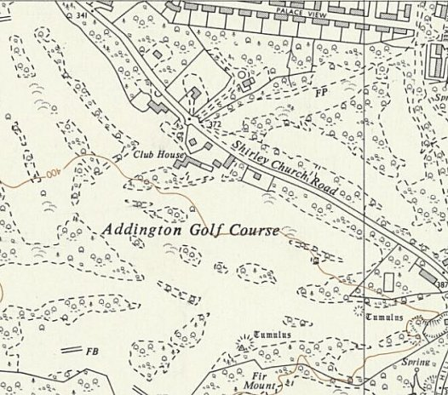
 | Ordnance Survey 1961

