Camp 238 Brook House, Hammingden Lane, Ardingly, Sussex

1947 Camp list
238(G.W.C.) | Brook House, Ardingly, Haywards Heath, Sussex | E. | Priswar, Haywards Heath | Ardingly 89 | Haywards Heath | Lt.Col.J.F.K. Ponsford | v/1453/2

Prisoner of War Camps (1939 – 1948) - Project report by Roger J.C. Thomas - English Heritage 2003
OS NGR | Sheet | No. | Name & Location | County | Cond’n | Type 1945 | Comments
TQ 357 293 | 187 | 238 | Brook House, Hammingden Lane, Ardingly | Sussex (West  Sussex) | 5 | German  Working Camp | Precise location not identified, NGR  given for Brook House

Location: Brook House shown on map. Hammingden Lane is the road shown running alongside Burstow / Upper Sheriff Farm / Hammingden Farm  Before the camp: Large country house and estate.  Pow Camp: The camp was located in the grounds of Brook House.  Foundations of huts have been found in the grounds. Names and dates of some pows are carved into the stone wall by the entrance to the main drive.  Camp commandant c1947 Lieutenant Colonel J F K Ponsford from the Queen’s Royal West Surrey Regiment.  After the camp: 2020 the large house has been converted to apartments.  Further Information:  National Archives FO 1120/234 – Re-educational survey visit reports for camps 236 to 239. Dated 1 Jan 1946 to 31 Dec 1948 | 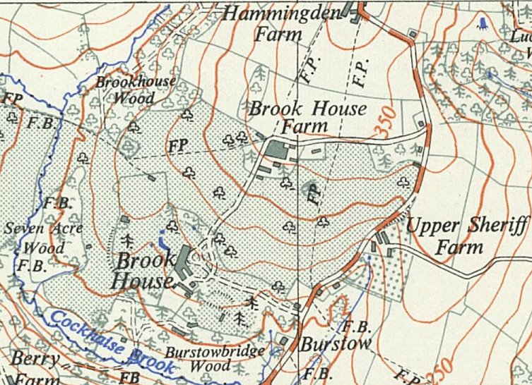
 | Ordnance Survey 1950

