Camp 237 Coed Bel Camp, Lubbock Road, Chislehurst, Kent

Included in the 1945 ICRC camp list – Labour Camp. 237. Co.Ed.Bel Camp, Lubbock Rd, Chislehurst, Kent.

1947 Camp list
237(G.W.C.) | Co-ed Bell Camp, Lubbock Road, Chislehurst, Kent. | L.D. | Priswar, Chislehurst | Imperial 1697 | Chislehurst (S.R.) | Major F.W. Lynch M.C. | v/1452/2

Prisoner of War Camps (1939 – 1948) - Project report by Roger J.C. Thomas - English Heritage 2003
OS NGR | Sheet | No. | Name & Location | County | Cond’n | Type 1945 | Comments
TQ 430 699 | 177 | 237 | Co-Ed-Bel Camp, Lubbock Road, Chislehurst | Kent | 5 | German  Working Camp | Precise location not identified, NGR  given for centre of Lubbock Road

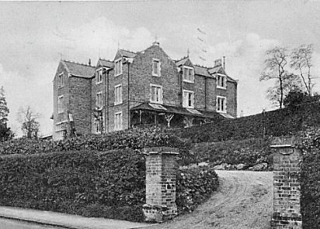  Location: NGR for Coed-bel house on Lubbock Road TQ 4305 7007  Before the camp: Built in 1865 by Welshman William Mostyn, the name is an adaption from Welsh. It was a private girls’ school from 1877. During the First World War the site was used as a nursing centre until 1919 when it reverted back to a school. The school relocated in 1940 and did not return to this site.  Pow Camp: The house as well as the grounds were used to house Italian and then German pows.  A hostel for the camp was located at Ravensbourne, Chislehurst, (from ‘Leben und Lernen hinter Stacheldraht’).  Camp commandant c1947 Major F W Lynch M.C. (I think he was from the King’s Regiment).  After the camp: Used for a while as a hostel by the Ministry of Defence. Old Coed-bel house demolished. 2020 Residential area.  Further Information: | 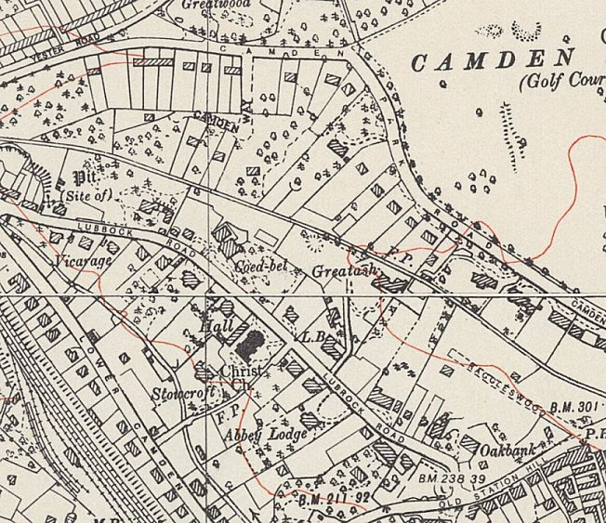
 | Ordnance Survey 1950
National Archives FO 1120/234 – Re-educational survey visit reports for camps 236 to 239. Dated 1 Jan 1946 to 31 Dec 1948

