Camp 236 White House, Church Hill, Loughton, Essex

Included in the 1945 ICRC Camp List – Labour Camp. 236. White House, Church Hill, Loughton, Essex.

Prisoner of War Camps (1939 – 1948) - Project report by Roger J.C. Thomas - English Heritage 2003
OS NGR | Sheet | No. | Name & Location | County | Cond’n | Type 1945 | Comments
TQ 441 963 | 167 | 236 | White House, Church Hill, Loughton | Essex | 4 |  | Site occupied by housing

Location: Grid reference above is shown on the map at position Y. However, the area known as ‘White House’ as shown on the 1896 OS map, was at location X.  Before the camp:  Pow Camp:  After the camp:  Further Information:  National Archives FO 1120/234 – Re-educational survey visit reports for camps 236 to 239. Dated 1 Jan 1946 to 31 Dec 1948 | 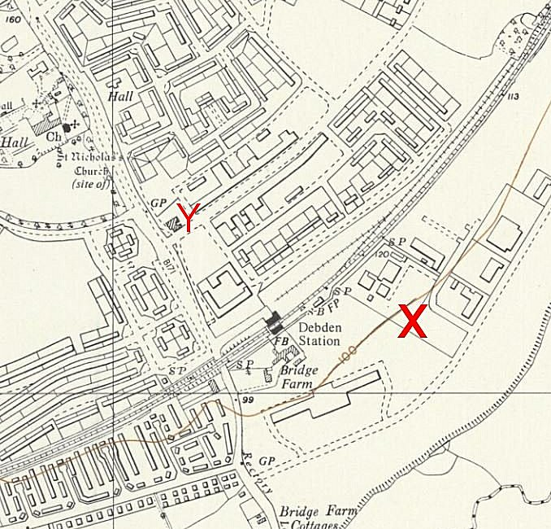
 | Ordnance Survey 1960

