Camp 236 Ninewells Camp, Chirnside, Berwickshire

1947 Camp List
236(G.W.C.) | “Nine Wells”, Chirnside, Duns, Berwickshire, Scotland | Sc | Priswar, Chirnside | Chirnside 259 | Duns | Lt.Col.D.Smith | v/1453/2

Prisoner of War Camps (1939 – 1948) - Project report by Roger J.C. Thomas - English Heritage 2003
OS NGR | Sheet | No. | Name & Location | County | Cond’n | Type 1945 | Comments
 |  | 236 | Nine Wells (Ninewells) Camp, Chirnside, Duns | Berwickshire |  | German Working Camp | Scotland

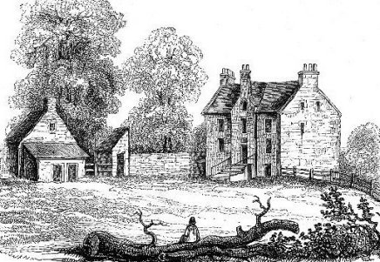  Location: NGR 8629 5575, at position X or just above in trees. Just SW of Chirnside village which is 14 km W of Berwick-upon-Tweed.  < early picture of the house.  Before the camp: Large house built 1839-41. Part of the 1st Polish Armoured Division were located here.  Pow Camp: Air photographs show at least 8 huts, mainly Nissen type – however the War establishment number and commandant’s rank indicate that a larger camp was here. The house itself may have been used.  Opening date? I have seen 1942, but I think the Polish Army was still there at that time.  Camp commandant c1947 Lieutenant Colonel D Smith  Postal items: 1946 letter-sheet in German to Germany.  After the camp: Hostel for displaced persons. The house was demolished - some sites say 1954, others 1964.  Further Information: | 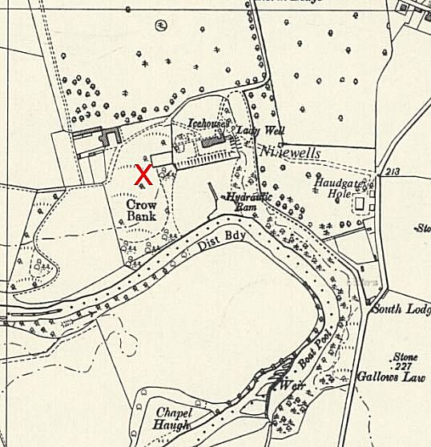
 | Ordnance Survey 1957
National Archives FO 1120/234 – Re-educational survey visit reports for camps 236 to 239. Dated 1 Jan 1946 to 31 Dec 1948

canmore.org.uk/site/272615 + canmore.org.uk/site/59681 – with some pictures and plans of Ninewells House.

Vertical air photographs (106G/Scot/UK 15, 7121-7122, flown 15 April 1946

