**Camp 235 T****he Arches, Felden, Hemel Hempstead, Hertfordshire**

|  |  |  |  |  |  |  |  |
| --- | --- | --- | --- | --- | --- | --- | --- |
| **1947 Camp List** | | | | | | | |
| 235(G.W.C.) | “The Arches”, Felden, Nr.Hemel Hempstead, Herts | E. | Priswar Hemel Hempstead | Boxmoor 785&996 | (Blank) | Lt.Col.R.M.Millar M.C. | v/1453/2 |

|  |  |  |  |  |  |  |  |
| --- | --- | --- | --- | --- | --- | --- | --- |
| **Prisoner of War Camps (1939 – 1948) - Project report by Roger J.C. Thomas - English Heritage 2003** | | | | | | | |
| OS NGR | Sheet | No. | Name & Location | County | Cond’n | Type 1945 | Comments |
| TL 040 050 | 166 | 235 | The Arches, Felden, Hemel Hempstead | Hertfordshire | 5 | German Working Camp | Precise location not identified, NGR given for centre village |

|  |  |
| --- | --- |
| **Location:** I found one reference to ‘The Arches’ – *“..Boxmoor has a station on the line and it is less than a mile – if a stiff uphill walk – from the station to a large house in comparatively rural surroundings, in a place too small to have a name, but nonetheless called Felden. Its isolation, hilltop setting and railway link made Felden the perfect place for foreign spies to keep an eye on an ally of dubious intentions. The house was called ‘The Arches’ and it was requisitioned by the British in May 1943….On 22 June 1943, the Polish Radio Intelligence Company commanded by Captain Kazimierz Zieliński moved into the house, in whose grounds there were now 8m radio masts and associated outbuildings…” (From ‘X, Y & Z: The Real Story of How Enigma Was Broken”*, by Dermot Turing). There is no trace of ‘The Arches’ on the maps I have seen, however, a plaque had been placed on the house to commemorate the work of the Radio Intelligence Company. Clive, a member of ww2talk.com did the leg work and found the house with the plaque – the house is now called ‘Widgeons’, it is in Streethanger Lane, Felden, NGR TL 04265 05464, area postcode HP3 0BQ. On earlier large scale maps it was labelled as ‘Widgeon’s Rest’ – I wonder if it was called ‘The Arches’ to add ‘camouflage’ to its location?  **Before the camp:** The Arches was used by the Polish Radio Intelligence Company from 1943 to 1945.  **Pow Camp:** The camp number was initially allocated to Gorhambury Park camp. Not known if the camp was in the house or the grounds to the rear. The War Establishment number and rank of the commandant shows that this was a fairly large camp, so I would guess it was in the grounds. |  |
| Ordnance Survey 1956 |

Camp Commandant c1947 Lieutenant Colonel R M Millar M.C. (I think he was from the Royal Armoured Corps).

**After the camp:** There is a plaque to the Polish Radio Intelligence Company on the house.<https://twitter.com/polishembassyuk/status/755731462985543680>

**Further Information:**

National Archives FO 1120/233 – Re-educational survey visit reports for camps 230 to 235. Dated 1 January 1946 to 31 December 1948

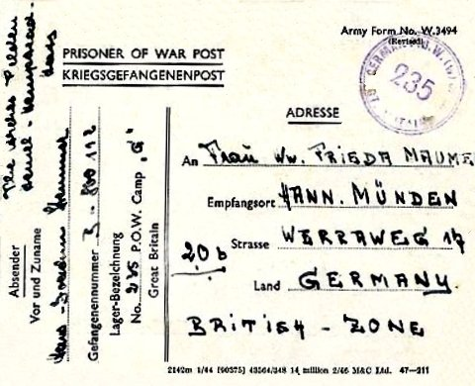

< Pow postcard dated 1947